 | 7.3.6 Editors - 3D Viewport - Sidebar - Tool Tab - Mesh - Sculpt Mode
Table of content
Detailed table of content 2
Tools Tab in Sculpt Mode 18
Brush Asset Panel 18
Brush Settings Panel 20
Brush Settings Panel - Common Settings 20
Brush Settings Panel - Blob brush 23
Brush Settings Panel - Clay brush 23
Brush Settings Panel - Clay Strips brush 24
Brush Settings Panel - Clay Thumb brush 25
Brush Settings Panel - Crease Polish brush 25
Brush Settings Panel - Crease Sharp brush 26
Brush Settings Panel - Draw brush 26
Brush Settings Panel - Draw Sharp brush 27
Brush Settings Panel - Inflate/Deflate brush 27
Brush Settings Panel - Layer brush 27
Brush Settings Panel - Fill/Deepen brush 28
Brush Settings Panel - Flatten/Contrast brush 29
Brush Settings Panel - Plateau brush 31
Brush Settings Panel - Scrape Multi-plane brush 32
Brush Settings Panel - Scrape/Fill brush 33
Brush Settings Panel - Smooth brush 34
Brush Settings Panel - Trim brush 35
Brush Settings Panel - Boundary brush 36
Brush Settings Panel - Elastic Grab brush 37
Brush Settings Panel - Elastic Snake Hook brush 37
Brush Settings Panel - Grab brush 38
Brush Settings Panel - Grab 2D brush 39
Brush Settings Panel - Grab Silhouette brush 39
Brush Settings Panel - Nudge brush 40
Brush Settings Panel - Pinch/Magnify brush 40
Brush Settings Panel - Pose brush 40
Brush Settings Panel - Pull brush 42
Brush Settings Panel - Relax Pinch brush 42
Brush Settings Panel - Relax Slide brush 43
Brush Settings Panel - Snake Hook brush 43
Brush Settings Panel - Thumb brush 44
Brush Settings Panel - Twist brush 44
Brush Settings Panel - Density brush 44
Brush Settings Panel - Erase multires displacement brush 44
Brush Settings Panel - Draw Face Sets brush 44
Brush Settings Panel - Mask brush 45
Brush Settings Panel - Smear Multires Displacement brush 45
Brush Settings Panel - Airbrush brush 46
Brush Settings Panel - Blend Hard brush 48
Brush Settings Panel - Blend Soft brush 50
Brush Settings Panel - Blend Square brush 52
Brush Settings Panel - Paint Blend brush 54
Brush Settings Panel - Paint Hard brush 56
Brush Settings Panel - Paint Hard Pressure brush 58
Brush Settings Panel - Paint Soft brush 60
Brush Settings Panel - Paint Soft Pressure brush 62
Brush Settings Panel - Paint Square brush 64
Brush Settings Panel - Sharpen brush 66
Brush Settings Panel - Smear brush 66
Brush Settings Panel - Bend Boundary Cloth brush 66
Brush Settings Panel - Bend/Twist Cloth brush 67
Brush Settings Panel - Drag Cloth brush 68
Brush Settings Panel - Expand/Contract Cloth brush 70
Brush Settings Panel - Grab Cloth brush 71
Brush Settings Panel - Grab Planar Cloth brush 73
Brush Settings Panel - Grab Random Cloth brush 74
Brush Settings Panel - Inflate Cloth brush 76
Brush Settings Panel - Pinch Folds Cloth brush 77
Brush Settings Panel - Pinch Point Cloth brush 79
Brush Settings Panel - Push Cloth brush 80
Brush Settings Panel - Stretch/Move Cloth brush 82
Brush Settings Panel - Twist Boundary Cloth brush 83
Brush Settings Panel - Color Picker Sub panel 84
Brush Settings Panel - Color Palette Sub panel 86
Brush Settings Panel - Advanced Sub panel 88
Brush Settings Panel - Texture Subpanel 92
Brush Settings Panel - Stroke Sub panel 98
Brush Settings Panel - Falloff Sub panel 107
Brush Settings Panel - Cursor Sub panel 108
Dyntopo Panel 109
Remesh Panel 111
Symmetry Panel 112
Options Panel 113

Detailed table of content

Detailed table of content
Detailed table of content 2
Tools Tab in Sculpt Mode 18
Brush Asset Panel 18
Browse Brush 18
Brush Specials menu 19
Edit Metadata 19
Catalog 19
Author 19
Desctription 19
OK / Cancel 19
Edit Preview Image 19
Save Brush Asset 19
Revert Brush Asset 19
Name 19
Brush Settings Panel 20
Brush Settings Panel - Common Settings 20
Size 20
Size Pressure 20
Pressure Size Curve 20
Selecting Points 20
Adding Points 21
Navigation elements 21
Zoom in 21
Zoom out 21
Clipping options 21
Tools 21
Reset View 21
Reset Curve 21
Handles 21
Position X / Y 21
Delete Points 21
Curve Presets 21
Use Unified Radius 21
Size Unit 21
Strength 22
Size Pressure 22
Use Unified Radius 22
Normal Radius 22
Hardness 22
Invert Pressure for Hardness 22
Use pressure for hardness 22
Autosmooth 22
Use pressure for hardness 22
Brush Settings Panel - Blob brush 23
Direction Add / Subtract 23
Magnify 23
Brush Settings Panel - Clay brush 23
Direction Add / Subtract 23
Plane Offset 23
Plane Trim 23
Brush Settings Panel - Clay Strips brush 24
Direction Add / Subtract 24
Plane Offset 24
Plane Trim 24
Distance 24
Tip roundness 24
Tip Scale X 24
Brush Settings Panel - Clay Thumb brush 25
Plane Offset 25
Plane Trim 25
Distance 25
Brush Settings Panel - Crease Polish brush 25
Direction Add / Subtract 25
Pinch 26
Brush Settings Panel - Crease Sharp brush 26
Direction Add / Subtract 26
Pinch 26
Brush Settings Panel - Draw brush 26
Direction Add / Subtract 26
Brush Settings Panel - Draw Sharp brush 27
Direction Add / Subtract 27
Brush Settings Panel - Inflate/Deflate brush 27
Direction Inflate / Deflate 27
Brush Settings Panel - Layer brush 27
Direction Add / Subtract 27
Height 28
Persistent 28
Set Persistent Base 28
Brush Settings Panel - Fill/Deepen brush 28
Direction Fill / Deepen 28
Plane Offset 28
Warning 28
Height 28
Depth 29
Area Radius 29
Size Pressure 29
Inversion Mode 29
Invert Displacement 29
Swap Height and Depth 29
Stabilize Normal 29
Stabilize Plane 29
Brush Settings Panel - Flatten/Contrast brush 29
Direction Fill / Deepen 30
Plane Offset 30
Warning 30
Height 30
Depth 30
Area Radius 30
Size Pressure 30
Inversion Mode 30
Invert Displacement 30
Swap Height and Depth 30
Stabilize Normal 30
Stabilize Plane 30
Brush Settings Panel - Plateau brush 31
Direction Fill / Deepen 31
Plane Offset 31
Warning 31
Height 31
Depth 31
Area Radius 31
Size Pressure 32
Inversion Mode 32
Invert Displacement 32
Swap Height and Depth 32
Stabilize Normal 32
Stabilize Plane 32
Brush Settings Panel - Scrape Multi-plane brush 32
Plane Angle 32
Dynamic Mode 32
Show Cursor Preview 32
Brush Settings Panel - Scrape/Fill brush 33
Direction Fill / Deepen 33
Plane Offset 33
Warning 33
Height 33
Depth 33
Area Radius 33
Size Pressure 34
Inversion Mode 34
Invert Displacement 34
Swap Height and Depth 34
Stabilize Normal 34
Stabilize Plane 34
Brush Settings Panel - Smooth brush 34
Direction Smooth / Enhance 34
Deformation 34
Laplacian 34
Surface 34
Brush Settings Panel - Trim brush 35
Direction Fill / Deepen 35
Plane Offset 35
Warning 35
Height 35
Depth 35
Area Radius 35
Size Pressure 36
Inversion Mode 36
Invert Displacement 36
Swap Height and Depth 36
Stabilize Normal 36
Stabilize Plane 36
Brush Settings Panel - Boundary brush 36
Deformation Target 36
Deformation 36
Boundary Falloff 37
Boundary Origin Offset 37
Brush Settings Panel - Elastic Grab brush 37
Normal Weight 37
Deformation 37
Volume Preservation 37
Brush Settings Panel - Elastic Snake Hook brush 37
Normal Weight 38
Magnify 38
Rake 38
Deformation 38
Brush Settings Panel - Grab brush 38
Normal Weight 38
Grab active Vertex 38
Grab Silhouette 38
Brush Settings Panel - Grab 2D brush 39
Normal Weight 39
Grab active Vertex 39
Grab Silhouette 39
Brush Settings Panel - Grab Silhouette brush 39
Normal Weight 39
Grab active Vertex 39
Grab Silhouette 39
Brush Settings Panel - Nudge brush 40
Brush Settings Panel - Pinch/Magnify brush 40
Direction Magnify / Pinch 40
Autosmooth 40
Brush Settings Panel - Pose brush 40
Deformation Target 41
Deformation 41
Lock Rotation when scaling 41
Rotation Origins 41
Pose Origin Offset 41
Smooth Iterations 41
Pose IK Segments 41
Keep Anchor Point 41
Connected only 41
Max Element Distance 41
Brush Settings Panel - Pull brush 42
Normal Weight 42
Magnify 42
Rake 42
Deformation 42
Brush Settings Panel - Relax Pinch brush 42
Deformation 42
Brush Settings Panel - Relax Slide brush 43
Deformation 43
Brush Settings Panel - Snake Hook brush 43
Normal Weight 43
Magnify 43
Rake 43
Deformation 43
Brush Settings Panel - Thumb brush 44
Brush Settings Panel - Twist brush 44
Brush Settings Panel - Density brush 44
Brush Settings Panel - Erase multires displacement brush 44
Brush Settings Panel - Draw Face Sets brush 44
Brush Settings Panel - Mask brush 45
Direction Add / Subtract 45
Mask Tool 45
Brush Settings Panel - Smear Multires Displacement brush 45
Deformation 45
Brush Settings Panel - Airbrush brush 46
Primary / Secondary color 46
Color picker 46
Swap Colors 46
Use Unified Color 46
Blend Mode 46
Flow 46
Invert pressure for flow 47
Use pressure for flow 47
Wet Mix 47
Invert pressure for Wet Mix 47
Use pressure for Wet Mix 47
Wet Persistence 47
Invert pressure for Wet Persistence 47
Use pressure for Wet Persistence 47
Wet Paint Radius 47
Density 47
Tip roundness 47
Tip Scale X 47
Brush Settings Panel - Blend Hard brush 48
Primary / Secondary color 48
Color picker 48
Swap Colors 48
Use Unified Color 48
Blend Mode 48
Flow 48
Invert pressure for flow 48
Use pressure for flow 49
Wet Mix 49
Invert pressure for Wet Mix 49
Use pressure for Wet Mix 49
Wet Persistence 49
Invert pressure for Wet Persistence 49
Use pressure for Wet Persistence 49
Wet Paint Radius 49
Density 49
Tip roundness 49
Tip Scale X 49
Brush Settings Panel - Blend Soft brush 50
Primary / Secondary color 50
Color picker 50
Swap Colors 50
Use Unified Color 50
Blend Mode 50
Flow 50
Invert pressure for flow 51
Use pressure for flow 51
Wet Mix 51
Invert pressure for Wet Mix 51
Use pressure for Wet Mix 51
Wet Persistence 51
Invert pressure for Wet Persistence 51
Use pressure for Wet Persistence 51
Wet Paint Radius 51
Density 51
Tip roundness 51
Tip Scale X 51
Brush Settings Panel - Blend Square brush 52
Primary / Secondary color 52
Color picker 52
Swap Colors 52
Use Unified Color 52
Blend Mode 52
Flow 52
Invert pressure for flow 53
Use pressure for flow 53
Wet Mix 53
Invert pressure for Wet Mix 53
Use pressure for Wet Mix 53
Wet Persistence 53
Invert pressure for Wet Persistence 53
Use pressure for Wet Persistence 53
Wet Paint Radius 53
Density 53
Tip roundness 53
Tip Scale X 53
Brush Settings Panel - Paint Blend brush 54
Primary / Secondary color 54
Color picker 54
Swap Colors 54
Use Unified Color 54
Blend Mode 54
Flow 54
Invert pressure for flow 54
Use pressure for flow 55
Wet Mix 55
Invert pressure for Wet Mix 55
Use pressure for Wet Mix 55
Wet Persistence 55
Invert pressure for Wet Persistence 55
Use pressure for Wet Persistence 55
Wet Paint Radius 55
Density 55
Tip roundness 55
Tip Scale X 55
Brush Settings Panel - Paint Hard brush 56
Primary / Secondary color 56
Color picker 56
Swap Colors 56
Use Unified Color 56
Blend Mode 56
Flow 56
Invert pressure for flow 56
Use pressure for flow 57
Wet Mix 57
Invert pressure for Wet Mix 57
Use pressure for Wet Mix 57
Wet Persistence 57
Invert pressure for Wet Persistence 57
Use pressure for Wet Persistence 57
Wet Paint Radius 57
Density 57
Tip roundness 57
Tip Scale X 57
Brush Settings Panel - Paint Hard Pressure brush 58
Primary / Secondary color 58
Color picker 58
Swap Colors 58
Use Unified Color 58
Blend Mode 58
Flow 58
Invert pressure for flow 59
Use pressure for flow 59
Wet Mix 59
Invert pressure for Wet Mix 59
Use pressure for Wet Mix 59
Wet Persistence 59
Invert pressure for Wet Persistence 59
Use pressure for Wet Persistence 59
Wet Paint Radius 59
Density 59
Tip roundness 59
Tip Scale X 59
Brush Settings Panel - Paint Soft brush 60
Primary / Secondary color 60
Color picker 60
Swap Colors 60
Use Unified Color 60
Blend Mode 60
Flow 60
Invert pressure for flow 61
Use pressure for flow 61
Wet Mix 61
Invert pressure for Wet Mix 61
Use pressure for Wet Mix 61
Wet Persistence 61
Invert pressure for Wet Persistence 61
Use pressure for Wet Persistence 61
Wet Paint Radius 61
Density 61
Tip roundness 61
Tip Scale X 61
Brush Settings Panel - Paint Soft Pressure brush 62
Primary / Secondary color 62
Color picker 62
Swap Colors 62
Use Unified Color 62
Blend Mode 62
Flow 62
Invert pressure for flow 63
Use pressure for flow 63
Wet Mix 63
Invert pressure for Wet Mix 63
Use pressure for Wet Mix 63
Wet Persistence 63
Invert pressure for Wet Persistence 63
Use pressure for Wet Persistence 63
Wet Paint Radius 63
Density 63
Tip roundness 63
Tip Scale X 63
Brush Settings Panel - Paint Square brush 64
Primary / Secondary color 64
Color picker 64
Swap Colors 64
Use Unified Color 64
Blend Mode 64
Flow 64
Invert pressure for flow 65
Use pressure for flow 65
Wet Mix 65
Invert pressure for Wet Mix 65
Use pressure for Wet Mix 65
Wet Persistence 65
Invert pressure for Wet Persistence 65
Use pressure for Wet Persistence 65
Wet Paint Radius 65
Density 65
Tip roundness 65
Tip Scale X 65
Brush Settings Panel - Sharpen brush 66
Deformation 66
Brush Settings Panel - Smear brush 66
Deformation 66
Brush Settings Panel - Bend Boundary Cloth brush 66
Deformation target 66
Deformation 67
Boundary Falloff 67
Boundary Origin Offset 67
Brush Settings Panel - Bend/Twist Cloth brush 67
Deformation target 67
Deformation 67
Rotation Origins 67
Pose Origin Offset 67
Smooth iterations 68
Pose IK Segments 68
Keep Anchor Point 68
Connected only 68
Max Element Distance 68
Brush Settings Panel - Drag Cloth brush 68
Persistent 68
Set Persistent Base 68
Simulation Area 68
Simulation Limit 69
Simulation Falloff 69
Deformation 69
Force Falloff 69
Cloth Mass 69
Cloth Damping 69
Soft Body Plasticity 69
Enable Collision 69
Brush Settings Panel - Expand/Contract Cloth brush 70
Persistent 70
Set Persistent Base 70
Simulation Area 70
Simulation Limit 70
Simulation Falloff 70
Deformation 70
Force Falloff 70
Cloth Mass 71
Cloth Damping 71
Soft Body Plasticity 71
Enable Collision 71
Brush Settings Panel - Grab Cloth brush 71
Persistent 71
Set Persistent Base 71
Simulation Area 71
Simulation Limit 72
Simulation Falloff 72
Pin Simulation Boundary 72
Deformation 72
Force Falloff 72
Cloth Mass 72
Cloth Damping 72
Soft Body Plasticity 72
Enable Collision 72
Brush Settings Panel - Grab Planar Cloth brush 73
Persistent 73
Set Persistent Base 73
Simulation Area 73
Simulation Limit 73
Simulation Falloff 73
Deformation 73
Force Falloff 73
Cloth Mass 74
Cloth Damping 74
Soft Body Plasticity 74
Enable Collision 74
Brush Settings Panel - Grab Random Cloth brush 74
Persistent 74
Set Persistent Base 74
Simulation Area 74
Simulation Limit 74
Simulation Falloff 75
Pin Simulation Boundary 75
Deformation 75
Force Falloff 75
Cloth Mass 75
Cloth Damping 75
Soft Body Plasticity 75
Enable Collision 75
Brush Settings Panel - Inflate Cloth brush 76
Persistent 76
Set Persistent Base 76
Simulation Area 76
Simulation Limit 76
Simulation Falloff 76
Deformation 76
Force Falloff 76
Cloth Mass 77
Cloth Damping 77
Soft Body Plasticity 77
Enable Collision 77
Brush Settings Panel - Pinch Folds Cloth brush 77
Persistent 77
Set Persistent Base 77
Simulation Area 77
Simulation Limit 78
Simulation Falloff 78
Deformation 78
Force Falloff 78
Cloth Mass 78
Cloth Damping 78
Soft Body Plasticity 78
Enable Collision 78
Brush Settings Panel - Pinch Point Cloth brush 79
Persistent 79
Set Persistent Base 79
Simulation Area 79
Simulation Limit 79
Simulation Falloff 79
Deformation 79
Force Falloff 79
Cloth Mass 80
Cloth Damping 80
Soft Body Plasticity 80
Enable Collision 80
Brush Settings Panel - Push Cloth brush 80
Persistent 80
Set Persistent Base 80
Simulation Area 80
Simulation Limit 80
Simulation Falloff 81
Deformation 81
Force Falloff 81
Cloth Mass 81
Cloth Damping 81
Soft Body Plasticity 81
Enable Collision 81
Brush Settings Panel - Stretch/Move Cloth brush 82
Deformation Target 82
Deformation 82
Rotation Origins 82
Pose Origin Offset 82
Smooth iterations 82
Lock Rotation When Scaling 82
Keep Anchor Point 82
Connected only 83
Max Element Distance 83
Brush Settings Panel - Twist Boundary Cloth brush 83
Deformation Target 83
Deformation 83
Boundary Falloff 83
Boundary Origin Offset 83
Brush Settings Panel - Color Picker Sub panel 84
Mode 84
Color / Gradient 84
Color picker mode 84
Colorpicker 84
Primary / Secondary color 84
Swap colors 84
Use Unified Color 84
Gradient mode 84
Color Ramp 84
Controls 84
+ 84
- 84
Tools menu 84
Flip Color Ramp 84
Distribute Stops from Left 85
Distribute Stops Evenly 85
Eyedropper (pipette icon) E 85
Reset Color Ramp 85
Color Mode 85
RGB 85
HSV/HSL 85
Interpolation 85
Ease 85
Cardinal 85
Linear 85
B-Spline 85
Constant 85
Color Ramp 85
Active Color Stop elements 85
Choose active color stop 85
Pos 86
Color 86
Background Color 86
Gradient Mapping 86
Pressure 86
Repeat 86
Gradient Spacing 86
Clamp 86
Gradient Spacing 86
Brush Settings Panel - Color Palette Sub panel 86
Palette browser 87
Edit Box 87
Number of users 87
Fake User 87
Add palette 87
Remove Palette 87
Add color 87
Remove color 87
Sort By 88
Brush Settings Panel - Advanced Sub panel 88
Brush Type 88
Automasking 89
Topology 89
Face Sets 89
Mesh Boundary 89
Face Sets Boundary 89
Cavity 89
Cavity (Inverted) 89
Create Mask 89
Factor 89
Blur 89
Custom Curve 90
Selecting Points 90
Adding Points 90
Navigation elements 90
Zoom in and out 90
Clipping Options 90
Use Clipping 90
Min and Max X Y 90
View Normal 90
Occlusion 90
Limit 91
Falloff 91
Area Normal 91
Limit 91
Falloff 91
Sculpt Plane 91
Use Original 91
Normal 91
Plane 91
Accumulate 91
Front Faces Only 91
Modes 92
Brush Settings Panel - Texture Subpanel 92
Browse Texture to be linked 92
Adding a texture 92
Texture Edit box 93
Brush Mapping 93
Brush Mapping with mapping method View Plane and Area Plane 94
Angle edit box 94
Rake 94
Random 94
Random edit box 94
Offset 94
Size 95
Sample Bias 95
Vector Displacement 95
Brush Mapping with mapping method Tiled 95
Angle edit box 95
Offset 95
Size 95
Sample Bias 95
Brush Mapping with mapping method 3D 96
Offset 96
Size 96
Sample Bias 96
Brush Mapping with mapping method Random 96
Angle edit box 97
Rake 97
Random 97
Random edit box 97
Offset 97
Size 97
Sample Bias 97
Brush Mapping with mapping method Stencil 97
Image Aspect 98
Angle edit box 98
Offset 98
Stencil Texture Controls 98
Brush Settings Panel - Stroke Sub panel 98
Stroke Panel with Stroke method Space 98
Spacing Edit Box 99
Spacing Pressure 99
Spacing Distance 99
Adjust Strength for Spacing 99
Dash Ratio 99
Dash Length 99
Jitter Edit Box 99
Jitter Pressure 99
Jitter Unit 99
Input Samples Edit Box 99
Stabilize Stroke 99
Smooth Stroke Radius Edit Box 100
Smooth Stroke Factor Edit Box 100
Stroke Panel with Stroke method Curve 100
Spacing Edit Box 101
Spacing Distance 101
Adjust Strength for Spacing 101
Paint Curve edit box 101
Draw Curve Button 101
Jitter Edit Box 101
Jitter Pressure 101
Jitter Unit 101
Input Samples Edit Box 102
Stroke Panel with Stroke method Line 102
Spacing Edit Box 102
Spacing Distance 102
Adjust Strength for Spacing 102
Jitter Edit Box 102
Jitter Pressure 103
Jitter Unit 103
Input Samples Edit Box 103
Stroke Panel with Stroke method Airbrush 103
Rate Edit Box 103
Spacing Distance 103
Jitter Edit Box 103
Jitter Pressure 103
Jitter Unit 104
Input Samples Edit Box 104
Stabilize Stroke 104
Smooth Stroke Radius Edit Box 104
Smooth Stroke Factor Edit Box 104
Stroke Panel with Stroke method Anchored 104
Edge to Edge 104
Spacing Distance 105
Input Samples Edit Box 105
Stroke Panel with Stroke method Drag dot 105
Spacing Distance 105
Input Samples Edit Box 105
Stroke Panel with Stroke method dot 106
Spacing Distance 106
Jitter Edit Box 106
Jitter Unit 106
Input Samples Edit Box 106
Stabilize Stroke 106
Smooth Stroke Radius Edit Box 106
Smooth Stroke Factor Edit Box 106
Brush Settings Panel - Falloff Sub panel 107
Presets 107
Selecting Points 107
Adding Points 107
Navigation elements 107
Zoom in and out 107
Tools 108
Reset View 108
Vector Handle 108
Auto Handle 108
Auto Clamped Handle 108
Reset Curve 108
Use Clipping 108
Delete Points 108
Curve Presets 108
Falloff Shape 108
Brush Settings Panel - Cursor Sub panel 108
Cursor checkbox in header 108
Cursor Color 109
Inverse Color 109
Falloff Opacity 109
Override Overlay 109
Use Cursor Overlay 109
Texture Opacity 109
Override Overlay 109
Use Cursor Overlay 109
Dyntopo Panel 109
Detailing 110
Relative Detail 110
Brush Detail 110
Constant Detail 110
Manual Detail 110
Refine method 110
Subdivide Collapse 110
Collapse Edges 110
Subdivide Edges 110
Resolution 110
Sample detail size picker 110
Remesh Panel 111
Mode 111
Voxel Size 111
Sample Detail Size 111
Adaptivity 111
Fix Poles 111
Smooth Normals 111
Preserve 111
Volume 111
Attributes 111
Voxel Remesh / Quadriflow Remesh 112
Symmetry Panel 112
Mirror 112
Lock 112
Tiling 112
Feather 112
Radial 113
Tile Offset 113
Symmetrize 113
Direction 113
Merge Distance 113
Symmetrize 113
Options Panel 113
Display 113
Fast Navigate 113
Delay Viewport Updates 113
Use Deform only 114
Display 114
Topology 114
Face Sets 114
Mesh Boundary 114
Face Sets Boundary 114
Cavity 114
Cavity ( Inverted) 114
Area Normal 114
View Normal 114
Propagation Steps 114
Gravity sub panel 114
Factor 114
Orientation 114

Tools Tab in Sculpt Mode

Sculpting is a process to deform the geometry by using a brush. Mesh objects, Grease Pencil objects and Hair Curve objects can be sculpted. In this chapter we handle the mesh tools. Grease Pencil and Curve Objects have their own chapter.
In Sculpt Mode you will mainly find settings for the different brushes, General settings, and brush specific settings. This settings can be found in different panels. The different brushes have different options and settings, dependent of which brush is selected. This brush specific options and settings are explained in the tool shelf chapter. Here we just cover the general panels with options and settings that exists for (nearly) all brushes.
The Sculpt Mode just exists for Mesh, Grease Pencil and Hair Curve objects.

Brush Asset Panel
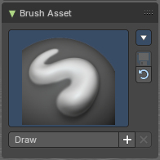
The Brush Asset Panel contains the different Brushes and some Brush settings. Choose and adjust your current active brush.

Browse Brush
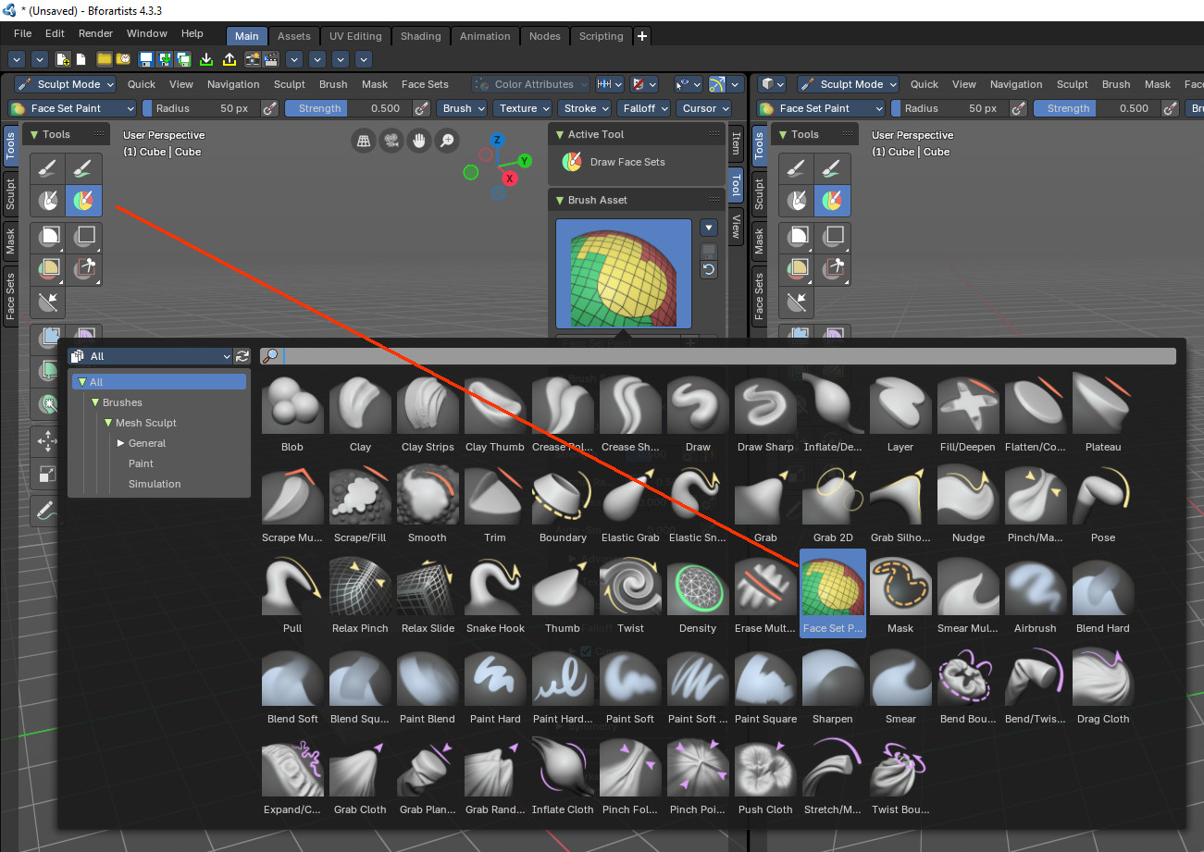
The big image at the top is a dropdown box that allows you to choose a brush. Click at it, and you will see the different brushes. A click at one of the images will choose this brush then.
Note that this browser shows all available brushes. Not only the ones that are meant for the current active tool in the tool shelf. And you might switch the tool by choosing another brush.
Brushes are assets. You can load them from different libraries if you want. Have a look at the brush asset browser at the bottom of the 3d view. Here the brushes are also categorized for easier access.
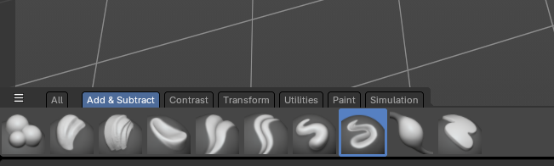

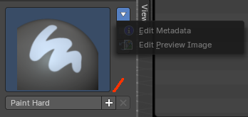
Brush Specials menu
This menu becomes active when you create a new brush. Which can be done wiht the Plus button in the name property. This data cannot be changed for builtin system brushes.

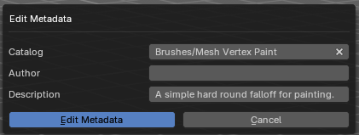
Edit Metadata
Calls a popup where you can adjust further informations and settings for the brush.

Catalog
The asset catalog in which the brush is stored.

Author
The brush author.

Desctription
Add a description

OK / Cancel
Accept or decline the changes.

Edit Preview Image
Allows you to load a custom preview image.

Save Brush Asset
This button is just active with a custom brush. It saves all changes made at the brush settings into the current custom brush.

Revert Brush Asset
Reverts the brush settings to the default values of the brush in the asset library.

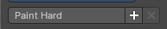
Name
The edit box below the Image shows the name of the current active brush.
The + button allows you to add a new pencil with the current settings. Note that the brushes are NOT automatically saved when you close Bforartists. You need to save the brush asset. See above.
The X button deletes the brush from the brushes list and from the asset library. This button is just active with a custom brush. You will be prompted by a warning so that you don't accidentally remove the brush.
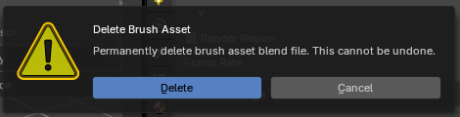

Brush Settings Panel
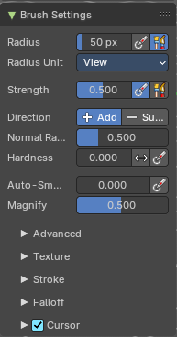
The Brush Settings Panel contains the Brush settings. The content differs, dependent of which brush you have chosen.

Brush Settings Panel - Common Settings

These settings can be found in all brushes.

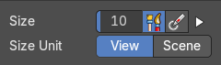
Size
The Radius edit box allows you to adjust the radius of the brush.

Size Pressure
The first button behind the edit box enables tablet pressure sensitivity for radius.

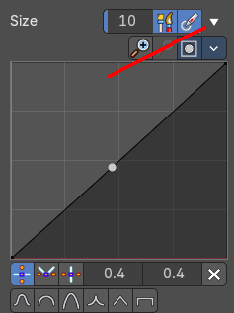
Pressure Size Curve
Behind the pressure size button there is a button to reveal the size pressure curve panel. When you activate Size Pressure for tablets, then the Size Pressure curve becomes active, and can be adjusted.
The pressure size curve allows you to adjust the falloff curve for the tablet pressure. It shows when Use Pressure is activated. The curve panel shows when clicking at the button.


Selecting Points
You can select curve points. This reveals two edit boxes for the x and y coordinate of this point.
Selected points can be moved around. Left click at them, hold the mouse button down and move them to a new location.


Adding Points
You can add new curve points by simply left clicking at the curve. Move the mouse to position them where you need it.

Navigation elements

Zoom in
Zooms in.

Zoom out
Zooms out.

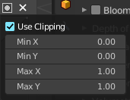
Clipping options
Set up clipping for the stroke.

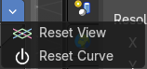
Tools
Tools is a menu where you can find some curve related tools.

Reset View
Resets the curve windows zoom.

Reset Curve
Resets the curve to the initial shape.

Handles
You can choose between Auto handle, Vector Handle and Auto Clamped.

Position X / Y
The position of the selectedc curve point.

Delete Points
Deletes the selected curve point.

Curve Presets
A curve preset to start with.

Use Unified Radius
The second button behind the edit box enables global radius size. Any modification at the radius will also modify the radius value for other paint tools.

Size Unit
Display the radius value in view units or in scene units. View units are by default in pixels, scene units in meters.

Strength
The Strength edit box allows you to adjust the strength of the brush.

Size Pressure
The first button behind the edit box enables tablet pressure sensitivity for radius.

Use Unified Radius
The second button behind the edit box enables global radius size. Any modification at the radius will also modify the radius value for other paint tools.
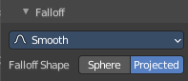
You need to have the fallof method set to Projected to activate the Front Faces Only checkbox.

Normal Radius
The ratio between the brush radius and the radius that is going to be used to sample the normal.

Hardness
How close the brush fallow starts from the edge of the brush.

Invert Pressure for Hardness
Invert the modulation of pressure in hardness.

Use pressure for hardness
Tablet feature. Use pressure to modulate hardness.

Autosmooth
The autosmooth edit box allows you to adjust the amount of smoothing that gets automatically applied to each stroke.

Use pressure for hardness
Tablet feature. Use pressure to modulate hardness.

Brush Settings Panel - Blob brush
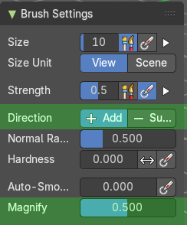
Add & subtract brushes for sculpting.

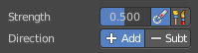
Direction Add / Subtract
Add means the stroke adds to the geometry. Subtract means the stroke subtracts from the geometry.

Magnify
The Crease Brush Pinch Factor.

Brush Settings Panel - Clay brush
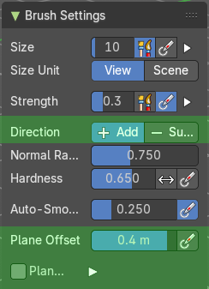
Add & subtract brushes for sculpting.

Direction Add / Subtract
Add means the stroke adds to the geometry. Subtract means the stroke subtracts from the geometry.

Plane Offset
Adjust the plane on which the brush acts towards or away from the objects surface. Sculpting with the Clay brush happens in a plane defined by the view you are in and the first vertices hit by the brush.

Plane Trim

Various brushes like Clay, Clay Thumb, Fill and Scrape brush. Enable Plane Trim. Sculpting with these brushes happens in a plane defined by the view you are in and the first vertices hit by the brush. The trim distance defines a limit above which vertices are not affected by the brush.

Brush Settings Panel - Clay Strips brush
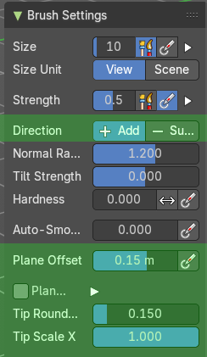
Add & subtract brushes for sculpting.

Direction Add / Subtract
Add means the stroke adds to the geometry. Subtract means the stroke subtracts from the geometry.

Plane Offset
Adjust the plane on which the brush acts towards or away from the objects surface. Sculpting with the Clay brush happens in a plane defined by the view you are in and the first vertices hit by the brush.

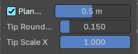
Plane Trim
Various brushes like Clay, Clay Thumb, Fill and Scrape brush. Enable Plane Trim. Sculpting with these brushes happens in a plane defined by the view you are in and the first vertices hit by the brush. The trim distance defines a limit above which vertices are not affected by the brush.

Distance
Adjust the plane trim distance.

Tip roundness
Roundness of the brush tip.

Tip Scale X
Scale of the tip in x direction.

Brush Settings Panel - Clay Thumb brush
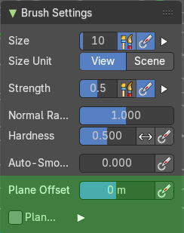
Add & subtract brushes for sculpting.

Plane Offset
Adjust the plane on which the brush acts towards or away from the objects surface. Sculpting with the Clay brush happens in a plane defined by the view you are in and the first vertices hit by the brush.

Plane Trim
Various brushes like Clay, Clay Thumb, Fill and Scrape brush. Enable Plane Trim. Sculpting with these brushes happens in a plane defined by the view you are in and the first vertices hit by the brush. The trim distance defines a limit above which vertices are not affected by the brush.

Distance
Adjust the plane trim distance.

Brush Settings Panel - Crease Polish brush

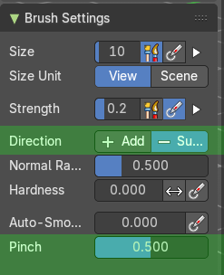
Add & subtract brushes for sculpting.

Direction Add / Subtract
Add means the stroke adds to the geometry. Subtract means the stroke subtracts from the geometry.

Pinch
The Crease Brush Pinch Factor.

Brush Settings Panel - Crease Sharp brush
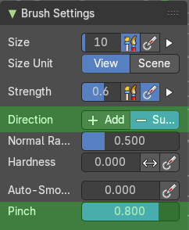
Add & subtract brushes for sculpting.

Direction Add / Subtract
Add means the stroke adds to the geometry. Subtract means the stroke subtracts from the geometry.

Pinch
The Crease Brush Pinch Factor.

Brush Settings Panel - Draw brush
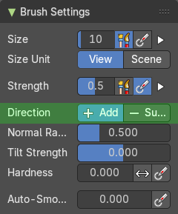
Add & subtract brushes for sculpting.

Direction Add / Subtract
Add means the stroke adds to the geometry. Subtract means the stroke subtracts from the geometry.

Brush Settings Panel - Draw Sharp brush
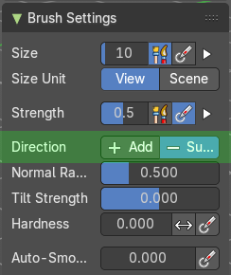
Add & subtract brushes for sculpting.

Direction Add / Subtract
Add means the stroke adds to the geometry. Subtract means the stroke subtracts from the geometry.

Brush Settings Panel - Inflate/Deflate brush
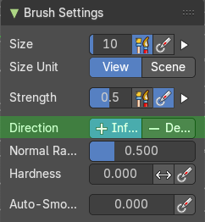
Contrast brushes for sculpting.

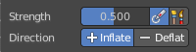
Direction Inflate / Deflate
Add or subtract effect of the brush.

Brush Settings Panel - Layer brush
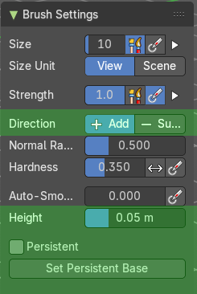
Contrast brushes for sculpting.

Direction Add / Subtract
Add means the stroke adds to the geometry. Subtract means the stroke subtracts from the geometry.

Height
Layer brush setting. The height that can be affected by the layer brush.

Persistent
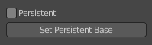
Layer brush setting. Sculpt on a persistent layer of the mesh.

Set Persistent Base
This button resets the base so that you can add another layer.

Brush Settings Panel - Fill/Deepen brush
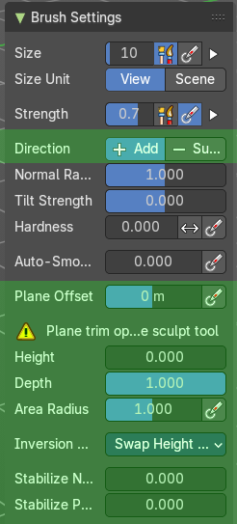
Contrast brushes for sculpting.

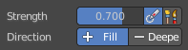
Direction Fill / Deepen
Add or subtract effect of the brush

Plane Offset
Adjust the plane on which the brush acts towards or away from the objects surface. Sculpting with the Clay brush happens in a plane defined by the view you are in and the first vertices hit by the brush.

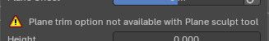
Warning
Just a warning that the plane trim option is not available for this brush.

Height
The maximum distance above the plane for affected vertices. Increasing the height affects vertices farther above the plane.

Depth
The maximum distance below the plane for affected vertices. Increasing the height affects vertices farther above the plane.

Area Radius
The ratio between the brush radius and the radius that is going to be used to sample the area center.

Size Pressure
Enables tablet pressure sensitivity for radius.

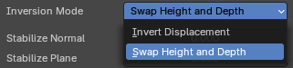
Inversion Mode

Invert Displacement
Displace the vertice away from the plane.

Swap Height and Depth
Swaps the roles of height and depth.

Stabilize Normal
Stabilize the orientation of the brush plane.

Stabilize Plane
Stabilize the orientation of the brush plane.

Brush Settings Panel - Flatten/Contrast brush
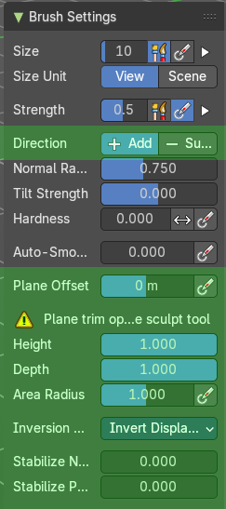
Contrast brushes for sculpting.

Direction Fill / Deepen
Add or subtract effect of the brush

Plane Offset
Adjust the plane on which the brush acts towards or away from the objects surface. Sculpting with the Clay brush happens in a plane defined by the view you are in and the first vertices hit by the brush.

Warning
Just a warning that the plane trim option is not available for this brush.

Height
The maximum distance above the plane for affected vertices. Increasing the height affects vertices farther above the plane.

Depth
The maximum distance below the plane for affected vertices. Increasing the height affects vertices farther above the plane.

Area Radius
The ratio between the brush radius and the radius that is going to be used to sample the area center.

Size Pressure
Enables tablet pressure sensitivity for radius.

Inversion Mode

Invert Displacement
Displace the vertice away from the plane.

Swap Height and Depth
Swaps the roles of height and depth.

Stabilize Normal
Stabilize the orientation of the brush plane.

Stabilize Plane
Stabilize the orientation of the brush plane.

Brush Settings Panel - Plateau brush

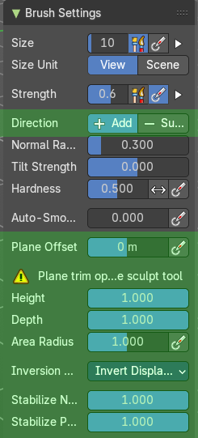
Contrast brushes for sculpting.

Direction Fill / Deepen
Add or subtract effect of the brush

Plane Offset
Adjust the plane on which the brush acts towards or away from the objects surface. Sculpting with the Clay brush happens in a plane defined by the view you are in and the first vertices hit by the brush.

Warning
Just a warning that the plane trim option is not available for this brush.

Height
The maximum distance above the plane for affected vertices. Increasing the height affects vertices farther above the plane.

Depth
The maximum distance below the plane for affected vertices. Increasing the height affects vertices farther above the plane.

Area Radius
The ratio between the brush radius and the radius that is going to be used to sample the area center.

Size Pressure
Enables tablet pressure sensitivity for radius.

Inversion Mode

Invert Displacement
Displace the vertice away from the plane.

Swap Height and Depth
Swaps the roles of height and depth.

Stabilize Normal
Stabilize the orientation of the brush plane.

Stabilize Plane
Stabilize the orientation of the brush plane.

Brush Settings Panel - Scrape Multi-plane brush
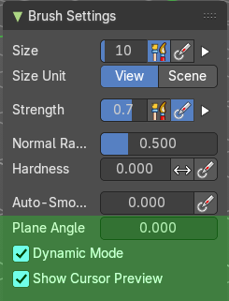
Contrast brushes for sculpting.

Plane Angle
Multiplane Scrape brush. The angles between the planes of the crease.

Dynamic Mode
Multiplane Scrape brush. Fit the angles during the stroke to fit the angles under the cursor.

Show Cursor Preview
Multiplane Scrape brush. Preview the plane scrapes in the cursor during the stroke.

Brush Settings Panel - Scrape/Fill brush

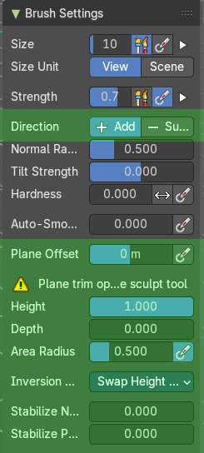
Contrast brushes for sculpting.

Direction Fill / Deepen
Add or subtract effect of the brush

Plane Offset
Adjust the plane on which the brush acts towards or away from the objects surface. Sculpting with the Clay brush happens in a plane defined by the view you are in and the first vertices hit by the brush.

Warning
Just a warning that the plane trim option is not available for this brush.

Height
The maximum distance above the plane for affected vertices. Increasing the height affects vertices farther above the plane.

Depth
The maximum distance below the plane for affected vertices. Increasing the height affects vertices farther above the plane.

Area Radius
The ratio between the brush radius and the radius that is going to be used to sample the area center.

Size Pressure
Enables tablet pressure sensitivity for radius.

Inversion Mode

Invert Displacement
Displace the vertice away from the plane.

Swap Height and Depth
Swaps the roles of height and depth.

Stabilize Normal
Stabilize the orientation of the brush plane.

Stabilize Plane
Stabilize the orientation of the brush plane.

Brush Settings Panel - Smooth brush
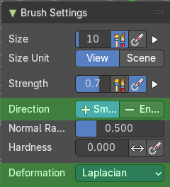
Contrast brushes for sculpting.

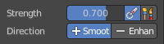
Direction Smooth / Enhance
Smooth or enhance the surface detail.

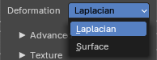
Deformation
Smooth or enhance the surface detail.

Laplacian
Smoothens the surface and the volume.

Surface
Smoothens the surface and preserves the volume.

Brush Settings Panel - Trim brush

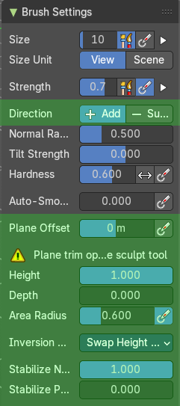
Contrast brushes for sculpting.

Direction Fill / Deepen
Add or subtract effect of the brush

Plane Offset
Adjust the plane on which the brush acts towards or away from the objects surface. Sculpting with the Clay brush happens in a plane defined by the view you are in and the first vertices hit by the brush.

Warning
Just a warning that the plane trim option is not available for this brush.

Height
The maximum distance above the plane for affected vertices. Increasing the height affects vertices farther above the plane.

Depth
The maximum distance below the plane for affected vertices. Increasing the height affects vertices farther above the plane.

Area Radius
The ratio between the brush radius and the radius that is going to be used to sample the area center.

Size Pressure
Enables tablet pressure sensitivity for radius.

Inversion Mode

Invert Displacement
Displace the vertice away from the plane.

Swap Height and Depth
Swaps the roles of height and depth.

Stabilize Normal
Stabilize the orientation of the brush plane.

Stabilize Plane
Stabilize the orientation of the brush plane.

Brush Settings Panel - Boundary brush
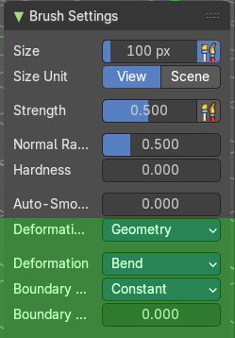
Transform brushes for sculpting.

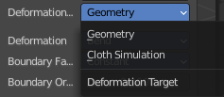
Deformation Target
The deformation type to use.

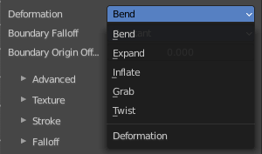
Deformation
The deformation type to use.

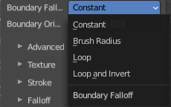
Boundary Falloff
Boundary brush option. The falloff type.

Boundary Origin Offset
Boundary brush option. Offset of the boundary origin in relation to the brush radius.

Brush Settings Panel - Elastic Grab brush

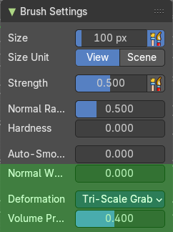
Transform brushes for sculpting.

Normal Weight
How much grab will pull vertexes out of surface during grab.

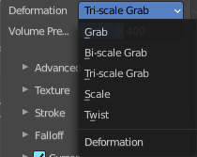
Deformation
The deformation type to use.

Volume Preservation
Poisson ratio for elastic deform. The higher the value is the more the volume is kept. But leads to more bulging

Brush Settings Panel - Elastic Snake Hook brush
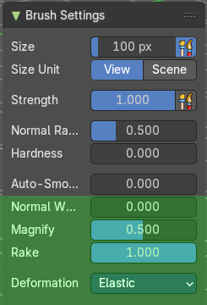
Transform brushes for sculpting.

Normal Weight
How much grab will pull vertexes out of surface during grab.

Magnify
The Crease Brush Pinch Factor.

Rake
How much grab will follow cursor rotation.

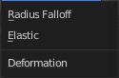
Deformation
The deformation type.

Brush Settings Panel - Grab brush
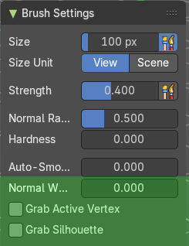
Transform brushes for sculpting.

Normal Weight
How much grab will pull vertexes out of surface during grab.

Grab active Vertex
Apply the maximum grab strength to the active vertex instead of the cursor position.

Grab Silhouette
Grab trying to automask the silhouette of the object.

Brush Settings Panel - Grab 2D brush

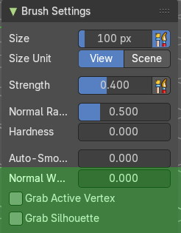
Transform brushes for sculpting.

Normal Weight
How much grab will pull vertexes out of surface during grab.

Grab active Vertex
Apply the maximum grab strength to the active vertex instead of the cursor position.

Grab Silhouette
Grab trying to automask the silhouette of the object.

Brush Settings Panel - Grab Silhouette brush

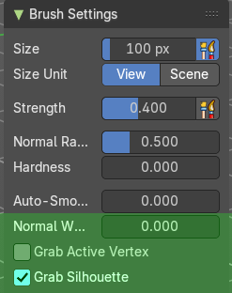
Transform brushes for sculpting.

Normal Weight
How much grab will pull vertexes out of surface during grab.

Grab active Vertex
Apply the maximum grab strength to the active vertex instead of the cursor position.

Grab Silhouette
Grab trying to automask the silhouette of the object.

Brush Settings Panel - Nudge brush
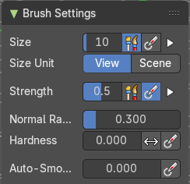
Transform brushes for sculpting.
Just standard settings.

Brush Settings Panel - Pinch/Magnify brush
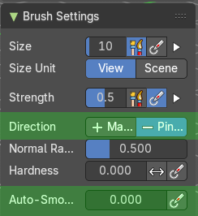
Transform brushes for sculpting.

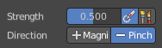
Direction Magnify / Pinch
Add or subtract effect of the brush.

Autosmooth
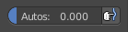
The autosmooth edit box allows you to adjust the amount of smoothing that gets automatically applied to each stroke. The button behind the edit box enables tablet pressure sensitivity for autosmooth.

Brush Settings Panel - Pose brush
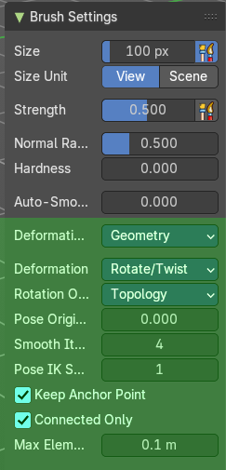
Transform brushes for sculpting.

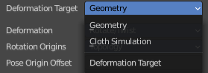
Deformation Target
Pose Brush setting. How the deformation of the brush will affect the object.

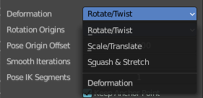
Deformation
Pose Brush setting. Deformation type that is used in the brush.

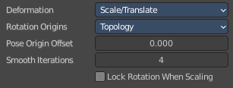
Lock Rotation when scaling
With Scale/Translate mode. Do not rotate the segment when using the scale deform mode.

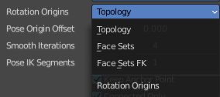
Rotation Origins
Pose Brush setting. Define the rotation origins.

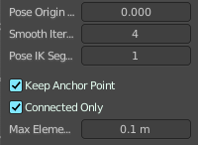
Pose Origin Offset
Pose Brush setting. Offset of the pose origin in relation to the brush radius.

Smooth Iterations
Pose Brush setting. Smooth iterations applied after calculating the pose factor of each vertex.

Pose IK Segments
Pose Brush setting. Number of segments of the IK chain that will deform the mesh.

Keep Anchor Point
Pose Brush setting. Keep the position of the last segment in the IK chain fixed.

Connected only
Affect only topology connected elements.

Max Element Distance
Maximum distance to search for disconnected loose parts in the mesh.

Brush Settings Panel - Pull brush
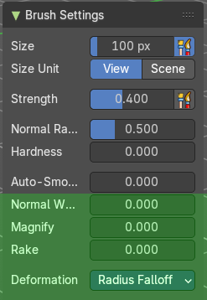
Transform brushes for sculpting.

Normal Weight
How much grab will pull vertexes out of surface during grab.

Magnify
The Crease Brush Pinch Factor.

Rake
How much grab will follow cursor rotation.

Deformation
The deformation type.

Brush Settings Panel - Relax Pinch brush

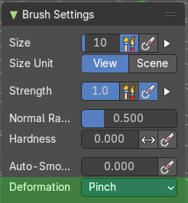
Transform brushes for sculpting.

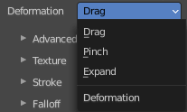
Deformation
The deformation type to use.

Brush Settings Panel - Relax Slide brush
Transform brushes for sculpting.

Deformation
The deformation type to use.

Brush Settings Panel - Snake Hook brush

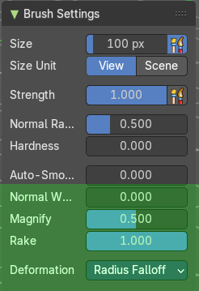
Transform brushes for sculpting.

Normal Weight
How much grab will pull vertexes out of surface during grab.

Magnify
The Crease Brush Pinch Factor.

Rake
How much grab will follow cursor rotation.

Deformation
The deformation type.

Brush Settings Panel - Thumb brush
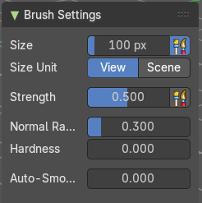
Transform brushes for sculpting.
Just standard settings.

Brush Settings Panel - Twist brush
Transform brushes for sculpting.
Just standard settings.

Brush Settings Panel - Density brush
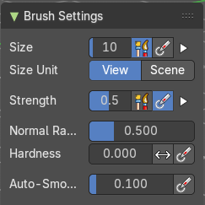
Utility brushes for sculpting.
Just standard settings.

Brush Settings Panel - Erase multires displacement brush
Utility brushes for sculpting.
Just standard settings.

Brush Settings Panel - Draw Face Sets brush
Utility brushes for sculpting.
Just standard settings.

Brush Settings Panel - Mask brush
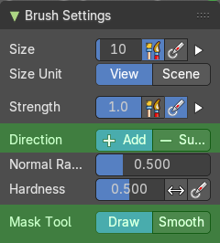
Utility brushes for sculpting.

Direction Add / Subtract
Add means the stroke adds to the geometry. Subtract means the stroke subtracts from the geometry.

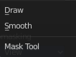
Mask Tool
Draw or smooth the current mask.

Brush Settings Panel - Smear Multires Displacement brush
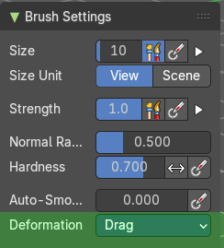
Utility brushes for sculpting.

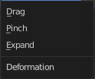
Deformation
The deformation method for the smear.

Brush Settings Panel - Airbrush brush

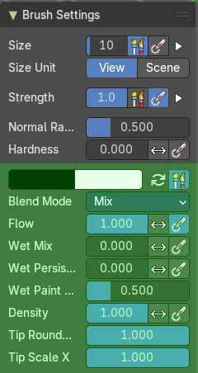
The airbrush brush allows you to vertex paint onto the sculpt mesh.

Primary / Secondary color
Set the primary and secondary color for painting.

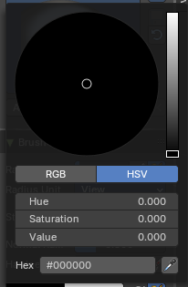
Color picker
Clicking at one of the colors will reveal a color wheel where you can adjust your color.

Swap Colors
Swaps the primary color with the secondary color.

Use Unified Color
The colors are shared across the brushes.

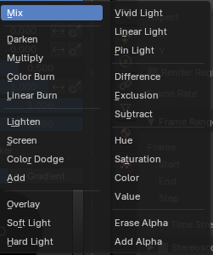
Blend Mode
The blend mode of the brush. How the color is applied.

Flow
Amount of color that is applied per stroke.

Invert pressure for flow
Invert the modulation of pressure.

Use pressure for flow
Use tablet pressure.

Wet Mix
Amount of color that is picked from the surface and mixed into the brush color.

Invert pressure for Wet Mix
Invert the modulation of pressure.

Use pressure for Wet Mix
Use tablet pressure.

Wet Persistence
Amount of wet paint that stays in the brush after applying paint at the surface.

Invert pressure for Wet Persistence
Invert the modulation of pressure.

Use pressure for Wet Persistence
Use tablet pressure.

Wet Paint Radius
Ratio between the brush ardius and the radius that is going to be used to sample the color to blend in wet paint.

Density
How dense the stroke is.

Tip roundness
Roundness of the brush tip.

Tip Scale X
Scale of the tip in x direction.

Brush Settings Panel - Blend Hard brush

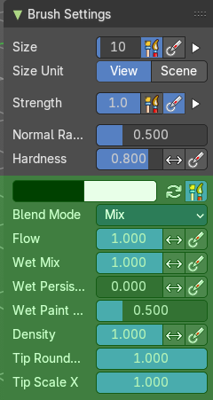
The blend hard brush allows you to vertex paint onto the sculpt mesh.

Primary / Secondary color
Set the primary and secondary color for painting.

Color picker
Clicking at one of the colors will reveal a color wheel where you can adjust your color.

Swap Colors
Swaps the primary color with the secondary color.

Use Unified Color
The colors are shared across the brushes.

Blend Mode
The blend mode of the brush. How the color is applied.

Flow
Amount of color that is applied per stroke.

Invert pressure for flow
Invert the modulation of pressure.

Use pressure for flow
Use tablet pressure.

Wet Mix
Amount of color that is picked from the surface and mixed into the brush color.

Invert pressure for Wet Mix
Invert the modulation of pressure.

Use pressure for Wet Mix
Use tablet pressure.

Wet Persistence
Amount of wet paint that stays in the brush after applying paint at the surface.

Invert pressure for Wet Persistence
Invert the modulation of pressure.

Use pressure for Wet Persistence
Use tablet pressure.

Wet Paint Radius
Ratio between the brush ardius and the radius that is going to be used to sample the color to blend in wet paint.

Density
How dense the stroke is.

Tip roundness
Roundness of the brush tip.

Tip Scale X

Brush Settings Panel - Blend Soft brush

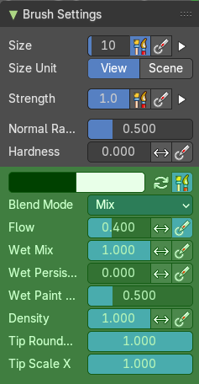
The blend soft brush allows you to vertex paint onto the sculpt mesh.

Primary / Secondary color
Set the primary and secondary color for painting.

Color picker
Clicking at one of the colors will reveal a color wheel where you can adjust your color.

Swap Colors
Swaps the primary color with the secondary color.

Use Unified Color
The colors are shared across the brushes.

Blend Mode
The blend mode of the brush. How the color is applied.

Flow
Amount of color that is applied per stroke.

Invert pressure for flow
Invert the modulation of pressure.

Use pressure for flow
Use tablet pressure.

Wet Mix
Amount of color that is picked from the surface and mixed into the brush color.

Invert pressure for Wet Mix
Invert the modulation of pressure.

Use pressure for Wet Mix
Use tablet pressure.

Wet Persistence
Amount of wet paint that stays in the brush after applying paint at the surface.

Invert pressure for Wet Persistence
Invert the modulation of pressure.

Use pressure for Wet Persistence
Use tablet pressure.

Wet Paint Radius
Ratio between the brush ardius and the radius that is going to be used to sample the color to blend in wet paint.

Density
How dense the stroke is.

Tip roundness
Roundness of the brush tip.

Tip Scale X
The scale of the tip in X direction.

Brush Settings Panel - Blend Square brush

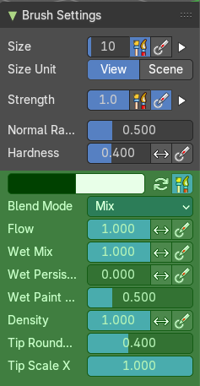
The blend square brush allows you to vertex paint onto the sculpt mesh.

Primary / Secondary color
Set the primary and secondary color for painting.

Color picker
Clicking at one of the colors will reveal a color wheel where you can adjust your color.

Swap Colors
Swaps the primary color with the secondary color.

Use Unified Color
The colors are shared across the brushes.

Blend Mode
The blend mode of the brush. How the color is applied.

Flow
Amount of color that is applied per stroke.

Invert pressure for flow
Invert the modulation of pressure.

Use pressure for flow
Use tablet pressure.

Wet Mix
Amount of color that is picked from the surface and mixed into the brush color.

Invert pressure for Wet Mix
Invert the modulation of pressure.

Use pressure for Wet Mix
Use tablet pressure.

Wet Persistence
Amount of wet paint that stays in the brush after applying paint at the surface.

Invert pressure for Wet Persistence
Invert the modulation of pressure.

Use pressure for Wet Persistence
Use tablet pressure.

Wet Paint Radius
Ratio between the brush ardius and the radius that is going to be used to sample the color to blend in wet paint.

Density
How dense the stroke is.

Tip roundness
Roundness of the brush tip.

Tip Scale X
The scale of the tip in X direction.

Brush Settings Panel - Paint Blend brush

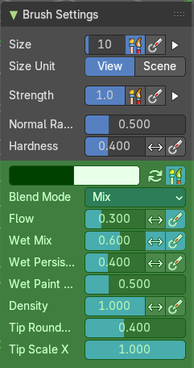
The paint blend brush allows you to vertex paint onto the sculpt mesh.

Primary / Secondary color
Set the primary and secondary color for painting.

Color picker
Clicking at one of the colors will reveal a color wheel where you can adjust your color.

Swap Colors
Swaps the primary color with the secondary color.

Use Unified Color
The colors are shared across the brushes.

Blend Mode
The blend mode of the brush. How the color is applied.

Flow
Amount of color that is applied per stroke.

Invert pressure for flow
Invert the modulation of pressure.

Use pressure for flow
Use tablet pressure.

Wet Mix
Amount of color that is picked from the surface and mixed into the brush color.

Invert pressure for Wet Mix
Invert the modulation of pressure.

Use pressure for Wet Mix
Use tablet pressure.

Wet Persistence
Amount of wet paint that stays in the brush after applying paint at the surface.

Invert pressure for Wet Persistence
Invert the modulation of pressure.

Use pressure for Wet Persistence
Use tablet pressure.

Wet Paint Radius
Ratio between the brush ardius and the radius that is going to be used to sample the color to blend in wet paint.

Density
How dense the stroke is.

Tip roundness
Roundness of the brush tip.

Tip Scale X
The scale of the tip in X direction.

Brush Settings Panel - Paint Hard brush

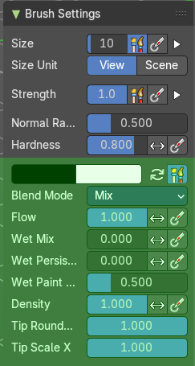
The paint hard brush allows you to vertex paint onto the sculpt mesh.

Primary / Secondary color
Set the primary and secondary color for painting.

Color picker
Clicking at one of the colors will reveal a color wheel where you can adjust your color.

Swap Colors
Swaps the primary color with the secondary color.

Use Unified Color
The colors are shared across the brushes.

Blend Mode
The blend mode of the brush. How the color is applied.

Flow
Amount of color that is applied per stroke.

Invert pressure for flow
Invert the modulation of pressure.

Use pressure for flow
Use tablet pressure.

Wet Mix
Amount of color that is picked from the surface and mixed into the brush color.

Invert pressure for Wet Mix
Invert the modulation of pressure.

Use pressure for Wet Mix
Use tablet pressure.

Wet Persistence
Amount of wet paint that stays in the brush after applying paint at the surface.

Invert pressure for Wet Persistence
Invert the modulation of pressure.

Use pressure for Wet Persistence
Use tablet pressure.

Wet Paint Radius
Ratio between the brush ardius and the radius that is going to be used to sample the color to blend in wet paint.

Density
How dense the stroke is.

Tip roundness
Roundness of the brush tip.

Tip Scale X
The scale of the tip in X direction.

Brush Settings Panel - Paint Hard Pressure brush

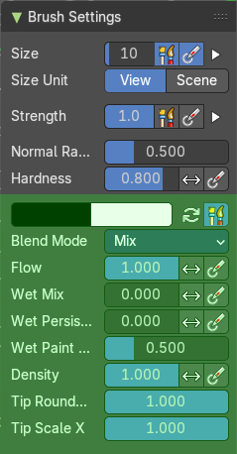
The paint hard pressure brush allows you to vertex paint onto the sculpt mesh.

Primary / Secondary color
Set the primary and secondary color for painting.

Color picker
Clicking at one of the colors will reveal a color wheel where you can adjust your color.

Swap Colors
Swaps the primary color with the secondary color.

Use Unified Color
The colors are shared across the brushes.

Blend Mode
The blend mode of the brush. How the color is applied.

Flow
Amount of color that is applied per stroke.

Invert pressure for flow
Invert the modulation of pressure.

Use pressure for flow
Use tablet pressure.

Wet Mix
Amount of color that is picked from the surface and mixed into the brush color.

Invert pressure for Wet Mix
Invert the modulation of pressure.

Use pressure for Wet Mix
Use tablet pressure.

Wet Persistence
Amount of wet paint that stays in the brush after applying paint at the surface.

Invert pressure for Wet Persistence
Invert the modulation of pressure.

Use pressure for Wet Persistence
Use tablet pressure.

Wet Paint Radius
Ratio between the brush ardius and the radius that is going to be used to sample the color to blend in wet paint.

Density
How dense the stroke is.

Tip roundness
Roundness of the brush tip.

Tip Scale X
The scale of the tip in X direction.

Brush Settings Panel - Paint Soft brush

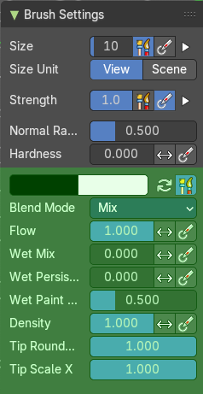
The airbrush brush allows you to vertex paint onto the sculpt mesh.

Primary / Secondary color
Set the primary and secondary color for painting.

Color picker
Clicking at one of the colors will reveal a color wheel where you can adjust your color.

Swap Colors
Swaps the primary color with the secondary color.

Use Unified Color
The colors are shared across the brushes.

Blend Mode
The blend mode of the brush. How the color is applied.

Flow
Amount of color that is applied per stroke.

Invert pressure for flow
Invert the modulation of pressure.

Use pressure for flow
Use tablet pressure.

Wet Mix
Amount of color that is picked from the surface and mixed into the brush color.

Invert pressure for Wet Mix
Invert the modulation of pressure.

Use pressure for Wet Mix
Use tablet pressure.

Wet Persistence
Amount of wet paint that stays in the brush after applying paint at the surface.

Invert pressure for Wet Persistence
Invert the modulation of pressure.

Use pressure for Wet Persistence
Use tablet pressure.

Wet Paint Radius
Ratio between the brush ardius and the radius that is going to be used to sample the color to blend in wet paint.

Density
How dense the stroke is.

Tip roundness
Roundness of the brush tip.

Tip Scale X
The scale of the tip in X direction.

Brush Settings Panel - Paint Soft Pressure brush

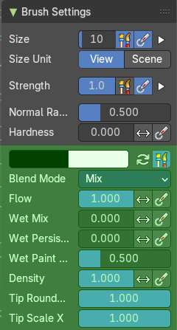
The Paint Soft Pressure brush allows you to vertex paint onto the sculpt mesh.

Primary / Secondary color
Set the primary and secondary color for painting.

Color picker
Clicking at one of the colors will reveal a color wheel where you can adjust your color.

Swap Colors
Swaps the primary color with the secondary color.

Use Unified Color
The colors are shared across the brushes.

Blend Mode
The blend mode of the brush. How the color is applied.

Flow
Amount of color that is applied per stroke.

Invert pressure for flow
Invert the modulation of pressure.

Use pressure for flow
Use tablet pressure.

Wet Mix
Amount of color that is picked from the surface and mixed into the brush color.

Invert pressure for Wet Mix
Invert the modulation of pressure.

Use pressure for Wet Mix
Use tablet pressure.

Wet Persistence
Amount of wet paint that stays in the brush after applying paint at the surface.

Invert pressure for Wet Persistence
Invert the modulation of pressure.

Use pressure for Wet Persistence
Use tablet pressure.

Wet Paint Radius
Ratio between the brush ardius and the radius that is going to be used to sample the color to blend in wet paint.

Density
How dense the stroke is.

Tip roundness
Roundness of the brush tip.

Tip Scale X
The scale of the tip in X direction.

Brush Settings Panel - Paint Square brush

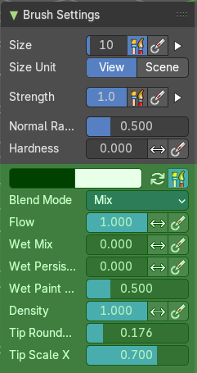
The Paint Square brush allows you to vertex paint onto the sculpt mesh.

Primary / Secondary color
Set the primary and secondary color for painting.

Color picker
Clicking at one of the colors will reveal a color wheel where you can adjust your color.

Swap Colors
Swaps the primary color with the secondary color.

Use Unified Color
The colors are shared across the brushes.

Blend Mode
The blend mode of the brush. How the color is applied.

Flow
Amount of color that is applied per stroke.

Invert pressure for flow
Invert the modulation of pressure.

Use pressure for flow
Use tablet pressure.

Wet Mix
Amount of color that is picked from the surface and mixed into the brush color.

Invert pressure for Wet Mix
Invert the modulation of pressure.

Use pressure for Wet Mix
Use tablet pressure.

Wet Persistence
Amount of wet paint that stays in the brush after applying paint at the surface.

Invert pressure for Wet Persistence
Invert the modulation of pressure.

Use pressure for Wet Persistence
Use tablet pressure.

Wet Paint Radius
Ratio between the brush ardius and the radius that is going to be used to sample the color to blend in wet paint.

Density
How dense the stroke is.

Tip roundness
Roundness of the brush tip.

Tip Scale X
The scale of the tip in X direction.

Brush Settings Panel - Sharpen brush
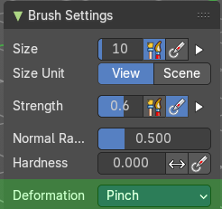
The Sharpen brush allows you to vertex paint onto the sculpt mesh.

Deformation
The deformation method for the smear.

Brush Settings Panel - Smear brush
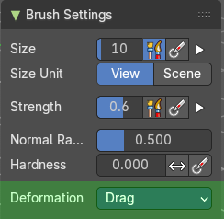
The Smear brush allows you to vertex paint onto the sculpt mesh.

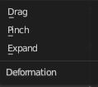
Deformation
How to deform the smearing.

Brush Settings Panel - Bend Boundary Cloth brush
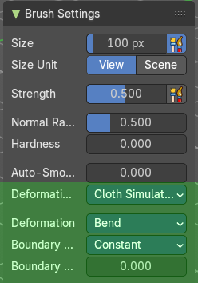
Simulation brushes allows you to sculpt and alter simulation data. To refine cloth simulations for example.

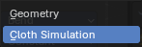
Deformation target
What data to affect. The simulation or the geometry.

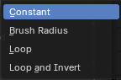
Deformation
What kind of deformation to apply.

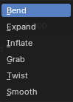
Boundary Falloff
The boundary falloff method.

Boundary Origin Offset
Offset of the boundary origin in relation to the brush radius.

Brush Settings Panel - Bend/Twist Cloth brush
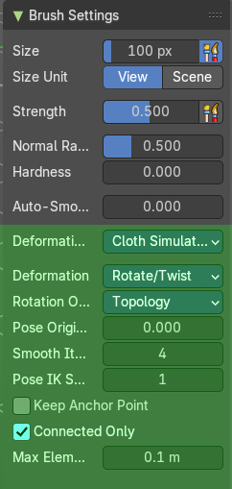
Simulation brushes allows you to sculpt and alter simulation data. To refine cloth simulations for example.

Deformation target
What data to affect. The simulation or the geometry.

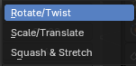
Deformation
What kind of deformation to apply.

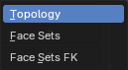
Rotation Origins
The point to bend or twist around.

Pose Origin Offset
Offset of the boundary origin in relation to the brush radius.

Smooth iterations
Number of smoothing steps after calculating the pose factor of each vertex.

Pose IK Segments
Numer of segments of the inverse kinematics chjain that will deform the mesh.

Keep Anchor Point
Keep the position of the last segment in the ik chain fixed.

Connected only
Affect only topological connected geometry.

Max Element Distance
Maximum distance to search for disconnected loose parts in the mesh

Brush Settings Panel - Drag Cloth brush
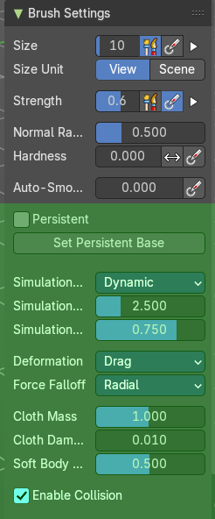
Simulation brushes allows you to sculpt and alter simulation data. To refine cloth simulations for example.

Persistent
Layer brush setting. Sculpt on a persistent layer of the mesh.

Set Persistent Base
This button resets the base so that you can add another layer.

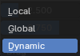
Simulation Area
What data to affect. The simulation or the geometry.

Simulation Limit
Factor to limit the cloth simulation effects.

Simulation Falloff
Area to apply the deformation falloff to the effects of the simulation.

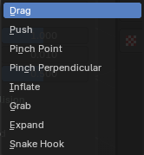
Deformation
What kind of deformation.

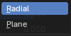
Force Falloff
Brush shape to apply force.

Cloth Mass
Mass of each simulation particle.

Cloth Damping
How much the applied forces are propagated through the cloth.

Soft Body Plasticity
How much the cloth preserves the original shap, acting as a softbody.

Enable Collision
Enable the collision with objects during the simulation.

Brush Settings Panel - Expand/Contract Cloth brush
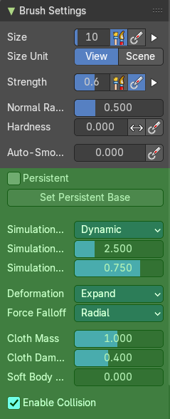
Simulation brushes allows you to sculpt and alter simulation data. To refine cloth simulations for example.

Persistent
Layer brush setting. Sculpt on a persistent layer of the mesh.

Set Persistent Base
This button resets the base so that you can add another layer.

Simulation Area
What data to affect. The simulation or the geometry.

Simulation Limit
Factor to limit the cloth simulation effects.

Simulation Falloff
Area to apply the deformation falloff to the effects of the simulation.

Deformation
What kind of deformation.

Force Falloff
Brush shape to apply force.

Cloth Mass
Mass of each simulation particle.

Cloth Damping
How much the applied forces are propagated through the cloth.

Soft Body Plasticity
How much the cloth preserves the original shap, acting as a softbody.

Enable Collision
Enable the collision with objects during the simulation.

Brush Settings Panel - Grab Cloth brush
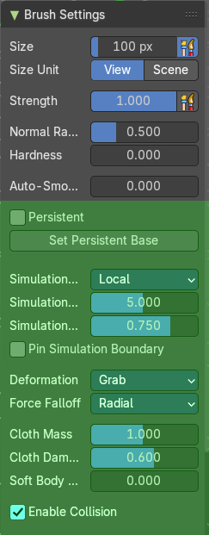
Simulation brushes allows you to sculpt and alter simulation data. To refine cloth simulations for example.

Persistent
Layer brush setting. Sculpt on a persistent layer of the mesh.

Set Persistent Base
This button resets the base so that you can add another layer.

Simulation Area
What data to affect. The simulation or the geometry.

Simulation Limit
Factor to limit the cloth simulation effects.

Simulation Falloff
Area to apply the deformation falloff to the effects of the simulation.

Pin Simulation Boundary
Lock the position of the vertices in the simulation falloff area. This can help to avoid artifacts, and creates a softer transition with unaffected areas.

Deformation
What kind of deformation.

Force Falloff
Brush shape to apply force.

Cloth Mass
Mass of each simulation particle.

Cloth Damping
How much the applied forces are propagated through the cloth.

Soft Body Plasticity
How much the cloth preserves the original shap, acting as a softbody.

Enable Collision
Enable the collision with objects during the simulation.

Brush Settings Panel - Grab Planar Cloth brush
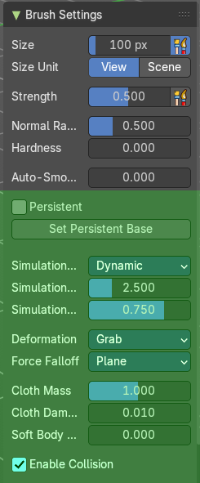
Simulation brushes allows you to sculpt and alter simulation data. To refine cloth simulations for example.

Persistent
Layer brush setting. Sculpt on a persistent layer of the mesh.

Set Persistent Base
This button resets the base so that you can add another layer.

Simulation Area
What data to affect. The simulation or the geometry.

Simulation Limit
Factor to limit the cloth simulation effects.

Simulation Falloff
Area to apply the deformation falloff to the effects of the simulation.

Deformation
What kind of deformation.

Force Falloff
Brush shape to apply force.

Cloth Mass
Mass of each simulation particle.

Cloth Damping
How much the applied forces are propagated through the cloth.

Soft Body Plasticity
How much the cloth preserves the original shap, acting as a softbody.

Enable Collision
Enable the collision with objects during the simulation.

Brush Settings Panel - Grab Random Cloth brush
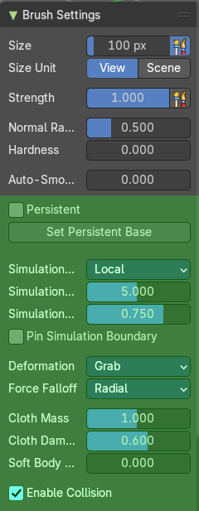
Simulation brushes allows you to sculpt and alter simulation data. To refine cloth simulations for example.

Persistent
Layer brush setting. Sculpt on a persistent layer of the mesh.

Set Persistent Base
This button resets the base so that you can add another layer.

Simulation Area
What data to affect. The simulation or the geometry.

Simulation Limit
Factor to limit the cloth simulation effects.

Simulation Falloff
Area to apply the deformation falloff to the effects of the simulation.

Pin Simulation Boundary
Lock the position of the vertices in the simulation falloff area. This can help to avoid artifacts, and creates a softer transition with unaffected areas.

Deformation
What kind of deformation.

Force Falloff
Brush shape to apply force.

Cloth Mass
Mass of each simulation particle.

Cloth Damping
How much the applied forces are propagated through the cloth.

Soft Body Plasticity
How much the cloth preserves the original shap, acting as a softbody.

Enable Collision
Enable the collision with objects during the simulation.

Brush Settings Panel - Inflate Cloth brush
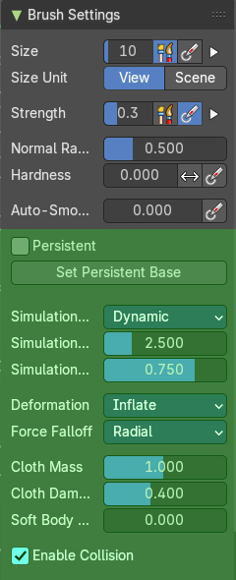
Simulation brushes allows you to sculpt and alter simulation data. To refine cloth simulations for example.

Persistent
Layer brush setting. Sculpt on a persistent layer of the mesh.

Set Persistent Base
This button resets the base so that you can add another layer.

Simulation Area
What data to affect. The simulation or the geometry.

Simulation Limit
Factor to limit the cloth simulation effects.

Simulation Falloff
Area to apply the deformation falloff to the effects of the simulation.

Deformation
What kind of deformation.

Force Falloff
Brush shape to apply force.

Cloth Mass
Mass of each simulation particle.

Cloth Damping
How much the applied forces are propagated through the cloth.

Soft Body Plasticity
How much the cloth preserves the original shap, acting as a softbody.

Enable Collision
Enable the collision with objects during the simulation.

Brush Settings Panel - Pinch Folds Cloth brush
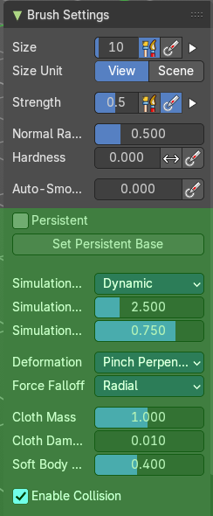
Simulation brushes allows you to sculpt and alter simulation data. To refine cloth simulations for example.

Persistent
Layer brush setting. Sculpt on a persistent layer of the mesh.

Set Persistent Base
This button resets the base so that you can add another layer.

Simulation Area
What data to affect. The simulation or the geometry.

Simulation Limit
Factor to limit the cloth simulation effects.

Simulation Falloff
Area to apply the deformation falloff to the effects of the simulation.

Deformation
What kind of deformation.

Force Falloff
Brush shape to apply force.

Cloth Mass
Mass of each simulation particle.

Cloth Damping
How much the applied forces are propagated through the cloth.

Soft Body Plasticity
How much the cloth preserves the original shap, acting as a softbody.

Enable Collision
Enable the collision with objects during the simulation.

Brush Settings Panel - Pinch Point Cloth brush
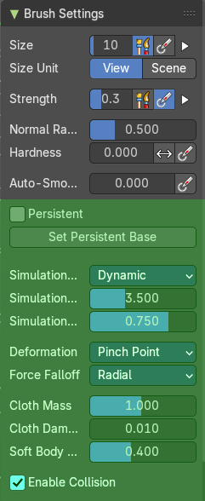
Simulation brushes allows you to sculpt and alter simulation data. To refine cloth simulations for example.

Persistent
Layer brush setting. Sculpt on a persistent layer of the mesh.

Set Persistent Base
This button resets the base so that you can add another layer.

Simulation Area
What data to affect. The simulation or the geometry.

Simulation Limit
Factor to limit the cloth simulation effects.

Simulation Falloff
Area to apply the deformation falloff to the effects of the simulation.

Deformation
What kind of deformation.

Force Falloff
Brush shape to apply force.

Cloth Mass
Mass of each simulation particle.

Cloth Damping
How much the applied forces are propagated through the cloth.

Soft Body Plasticity
How much the cloth preserves the original shap, acting as a softbody.

Enable Collision
Enable the collision with objects during the simulation.

Brush Settings Panel - Push Cloth brush
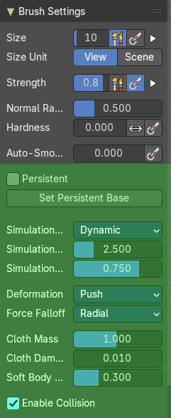
Simulation brushes allows you to sculpt and alter simulation data. To refine cloth simulations for example.

Persistent
Layer brush setting. Sculpt on a persistent layer of the mesh.

Set Persistent Base
This button resets the base so that you can add another layer.

Simulation Area
What data to affect. The simulation or the geometry.

Simulation Limit
Factor to limit the cloth simulation effects.

Simulation Falloff
Area to apply the deformation falloff to the effects of the simulation.

Deformation
What kind of deformation.

Force Falloff
Brush shape to apply force.

Cloth Mass
Mass of each simulation particle.

Cloth Damping
How much the applied forces are propagated through the cloth.

Soft Body Plasticity
How much the cloth preserves the original shap, acting as a softbody.

Enable Collision
Enable the collision with objects during the simulation.

Brush Settings Panel - Stretch/Move Cloth brush
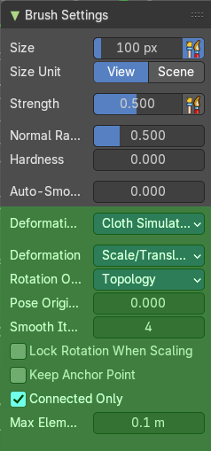
Simulation brushes allows you to sculpt and alter simulation data. To refine cloth simulations for example.

Deformation Target
The deformation type to use.

Deformation
The deformation type to use.

Rotation Origins
The point to bend or twist around.

Pose Origin Offset
Offset of the boundary origin in relation to the brush radius.

Smooth iterations
Number of smoothing steps after calculating the pose factor of each vertex.

Lock Rotation When Scaling
Lock the rotation when scaling.

Keep Anchor Point
Keep the position of the last segment in the ik chain fixed.

Connected only
Affect only topological connected geometry.

Max Element Distance
Maximum distance to search for disconnected loose parts in the mesh.

Brush Settings Panel - Twist Boundary Cloth brush
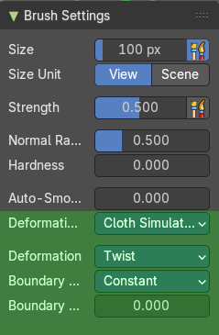
Simulation brushes allows you to sculpt and alter simulation data. To refine cloth simulations for example.

Deformation Target
The deformation type to use.

Deformation
The deformation type to use.

Boundary Falloff
The boundary falloff method.

Boundary Origin Offset
Offset of the boundary origin in relation to the brush radius.

Brush Settings Panel - Color Picker Sub panel

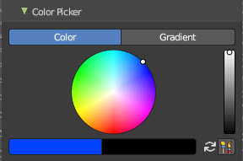
Paint brushes only. This sub panel is for the vertex painting paint tool. Define the primary and secondary color for the paint by a color picker and gradient dialog.

Mode

Color / Gradient
Choose the color mode.

Color picker mode

Colorpicker
The color wheel of the color picker.

Primary / Secondary color
Set the primary and secondary color for painting.

Swap colors
Swap the primary with the secondary color.

Use Unified Color
Use the same color over all editors and modes.

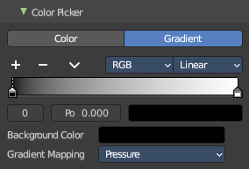
Gradient mode
Allows you to paint gradients.

Color Ramp
Color Ramps enables the user to specify a range of colors based on color stops. The color between the color stops gets interpolated.

Controls

+
Add a stop to your color ramp. The stop will be added after the selected one, in the middle to the next one.

-
Deletes the selected color stop from the list.


Tools menu

Flip Color Ramp
Flips the gradient, inverting the values of the color ramp.

Distribute Stops from Left
Rearrange the stops so that every step has the same space to the right.

Distribute Stops Evenly
Space between all neighboring stops becomes equal.

Eyedropper (pipette icon) E
An Eyedropper to sample a color or gradient from the interface to be used in the color ramp.

Reset Color Ramp

Resets the color ramp to its default state.

Color Mode

RGB
Blends color by mixing each color channel and combining.

HSV/HSL
Blends colors by first converting to HSV or HSL, mixing, then combining again. This has the advantage of maintaining saturation between different hues, where RGB would de-saturate, this allows for a richer gradient.


Interpolation

Ease
Uses an Ease Interpolation for the color stops.

Cardinal
Uses a Cardinal Interpolation for the color stops.

Linear
Uses a Linear Interpolation for the color stops.

B-Spline
Uses a B-Spline Interpolation for the color stops.

Constant
Uses a Constant Interpolation for the color stops.

Color Ramp
The color band. A click at one of the color stops makes it the active one. You can move the color stops by clicking at them and dragging them around.

Active Color Stop elements
Adjust the active color stop.

Choose active color stop
Choose the color stop by index.

Pos
The position of the active color stop. The range goes from 0.000 to 1.000

Color
The color of the active color stop. Click at it to change the color.

Background Color
The background color.

Gradient Mapping
How to paint the gradient.

Pressure
Paint the gradient by tablet pressure. Obviously you need a tablet for this.

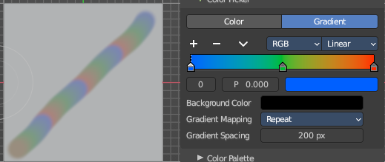
Repeat
Paint the gradient by repeating the colors.

Gradient Spacing
The spacing between the colors in screen pixels. You need to have a gradient spacing higher than 0.

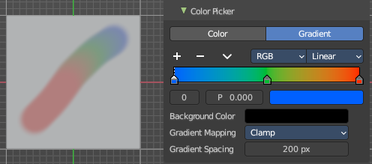
Clamp
Paint the gradient from first color to last color, and then sticks with the last color. You need to have a gradient spacing higher than 0.

Gradient Spacing
The spacing between the colors in screen pixels.

Brush Settings Panel - Color Palette Sub panel

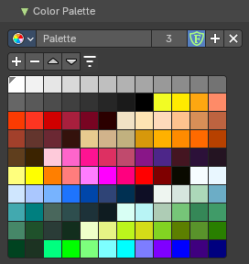
Paint brushes only. A color palette. There is a premade palette, and you can create your own palette of colors.

This sub panel just shows with the paint tool. Define a color palette to use for vertex painting.
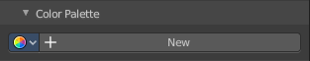
Create a color palette for later reuse.
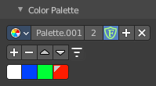
First create a new palette by clicking at New. Then adjust the color in the color picker. And then click at the add button to add this color to the palette.
To set the color picker to a palette color simply click at this palette color.
To remove a color from the palette, choose it, then click at the remove button. The active palette color that gets removed is the one with the triangle at it.
The color palette cannot be saved externally. It is part of the current blend file. You can however append color palettes from other blend files.
The currently active color is the one with the triangle at it.
The elements are explained from left to right.

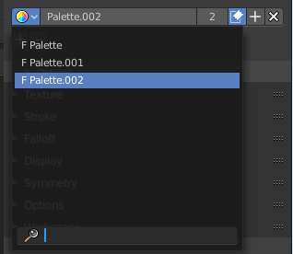
Palette browser
The button at the left opens a dropdown list. Choose between your palettes.

Edit Box
The name of the currently active palette. You can also rename the palette here. A click into the edit box makes the name editable.

Number of users
See how many users the palette currently has.

Fake User
Fake User sets the element to have a fake user. Zero user data-blocks are normally not saved. But sometimes you want to force the data to be kept even when the data block has no user.

Add palette
Add a new palette.

Remove Palette
Clicking at this button removes the palette. Note that you need to save, close Bforartists and reload the blend file to remove the palette completely.

Add color
Adjust a color in the color picker. Then click at the add button to add this color to the palette.

Remove color
Select the color in the palette, then click at the minus button to remove it.

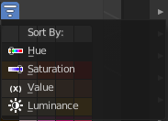
Sort By
Sort the palette by the chosen method.

Brush Settings Panel - Advanced Sub panel
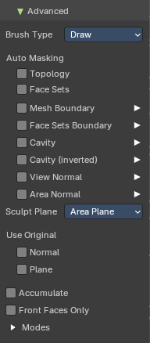
In this sub panel you can find the not so often used settings. They differ from brush to brush. Have a look at the tool tips.

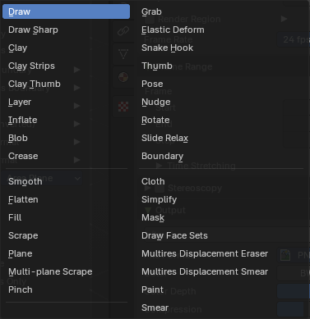
Brush Type
Dropdown box to display and to change the brush type. Note that the brush type is already given by the brush that you choose.

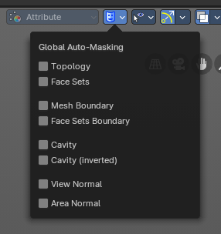
Automasking
In this group of properties toggles you can define Auto-Masking settings per brush. The same content can also be found in the header. But here as global settings. Note: These override any brush Auto-Masking settings.

Topology
Affect only vertices that are connected to the current active vertex under the brush.

Face Sets
Affect only vertices that share face sets with the active vertex.

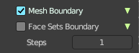
Mesh Boundary
Do not affect non manifold boundary edges.
The setting that appears on activation and is valid for both, Mesh Boundary and Face Sets Boundary.

Face Sets Boundary
Do not affect vertices that belong to a face set boundary.
The setting that appears on activation and is valid for both, Mesh Boundary and Face Sets Boundary.

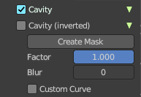
Cavity
Do not affect vertices on peaks. This feature is based on the surface curvature.
The setting that appears on activation and is valid for both, Cavity, and Cavity (Inverted).

Cavity (Inverted)
Do not affect vertices in valleys. This feature is based on the surface curvature.
The setting that appears on activation and is valid for both, Cavity, and Cavity (Inverted).

Create Mask
Creates a mask based on the curvature of the surface.

Factor
The contrast of the cavity mask.

Blur
The number of times the cavity mask is blurred

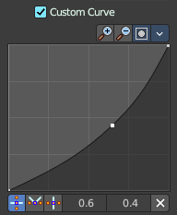
Custom Curve
Use a custom falloff curve for the cavity mask.

Selecting Points
You can select curve points. This reveals two edit boxes for the x and y coordinate of this point.
Selected points can be moved around. Left click at them, hold the mouse button down and move them to a new location.

Adding Points
You can add new curve points by simply left clicking at the curve. Move the mouse to position them where you need it.

Navigation elements
The navigation elements at the top are described from left to right.

Zoom in and out
The two buttons with the magnifying glass at it zooms in and out in the curve window.

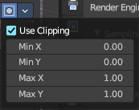
Clipping Options
Set up clipping for the stroke.

Use Clipping
Turns clipping on or off.

Min and Max X Y
The values for the clipping area.

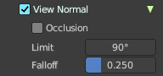
View Normal
Affect only vertices with a normal that faces the viewer.

Occlusion
Only affect vertices that are not occluded by other faces. With Occlusion on the Limit and Falloff options are not available.

Limit
View normal limit. The range of angles that will be affected.

Falloff
Extend the angular range with a falloff gradient.

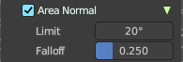
Area Normal
Affect only vertices with a similar normal to where the stroke starts.

Limit
Area normal limit. The range of angles that will be affected.

Falloff
Extend the angular range with a falloff gradient.

Sculpt Plane
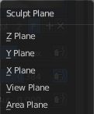
The sculpt plane defines how the sculpting is aligned. It is a dropdown box. Choose different methods. By default the Area Plane gets used.

Use Original

Normal
When ticked keep using normal of the surface where the stroke was initiated.

Plane
When ticked keep using plane origin of the surface where the stroke was initiated.

Accumulate
Accumulate stroke daubts on top of each other.

Front Faces Only
The brush only affects the vertices that faces the viewer. Projected Falloff Only.

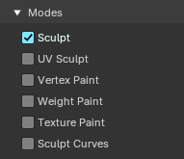
Modes
In which mode this brush will be available

Brush Settings Panel - Texture Subpanel
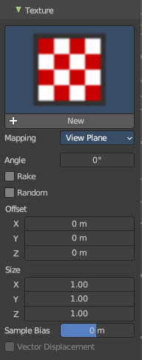
The Texture panel allows you to sculpt with textures. This allows you for example to grab a foto from some fish scales, and simply sculpt them into the surface of your object by using this image as a pencil. Or as a blueprint where you calk through ( Stencil method ).
Note that the following shots are made with Symmetry off and without Brush falloff. Since they disturbed.

Symmetry can be turned off a few panels deeper in the Symmetry panel.

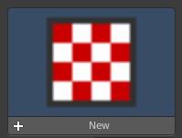
Browse Texture to be linked
The image at the top of the panel is a image browser. Choose a texture that you can choose for sculpting then. You can also have more than one image loaded at once.

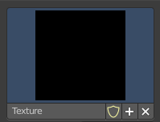
Adding a texture

The way to add the texture here is a bit more complicated. And not done with clicking at the New button.
First click at the New button below the image. This will create a new texture slot. This slot is still empty, it displays black.
We need to load the texture in this slot. This must be done in the Properties editor in the Textures tab.
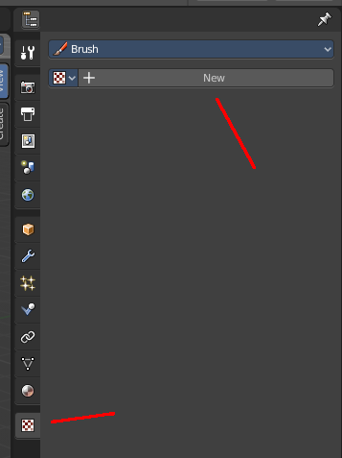
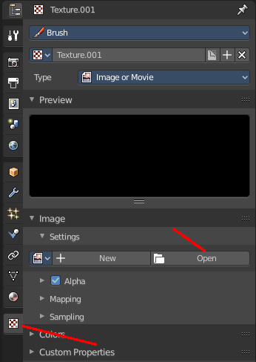
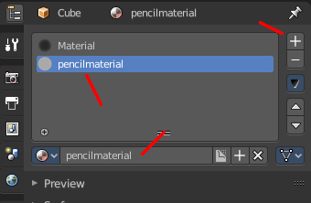
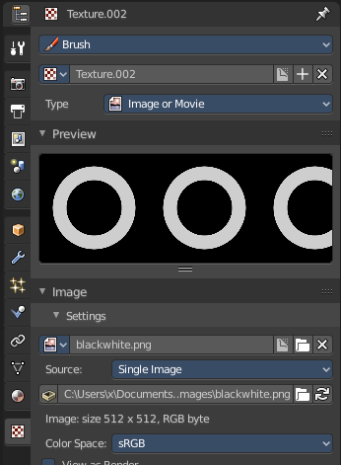

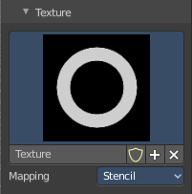
And when you switch back to the Tools tab, then the texture finally shows in the Texture panel in the Tool Shelf. And we can use it.

Texture Edit box
The Texture edit box is the edit box below the Image browser. When there's no image loaded then it displays the New button. When there's a image (or more) loaded, then you will see the name of the current texture.
The Fake User button turns this texture into a data block with a fake user. Means it will exists even when there is no data connected to it anymore.
The + Button adds another texture slot. Note that you will have to load a texture too, as explained above.
The X button deletes the texture slot.

Brush Mapping
Our texture can be mapped in different methods. The Brush mapping is a drop down box. Choose this different brush mapping methods.
The settings vary. So we will go through them by the different brush mapping methods.

Brush Mapping with mapping method View Plane and Area Plane
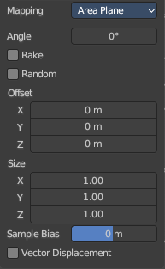
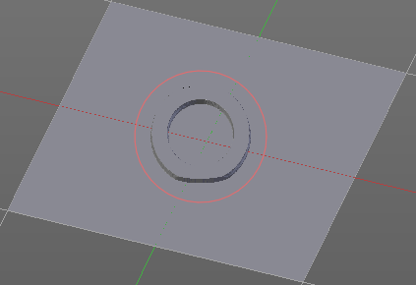
The brush mapping method View Plane maps the brush onto the surface of the object, calculating the mapping from the current view. The result may be distorted when the view does not align with the surface of the object.
The brush mapping method Area Plane maps the brush onto the surface of the object, calculating the mapping from the current view. The result is not distorted.

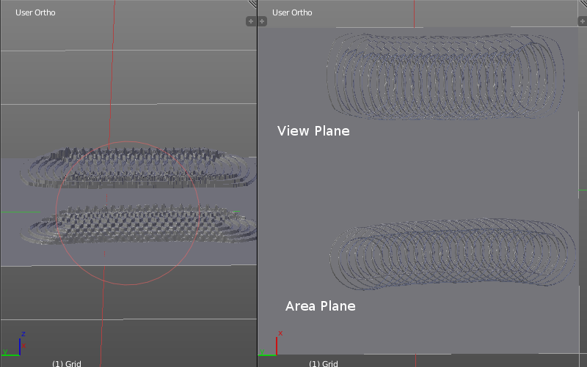
Angle edit box
Adjust the angle of the brush.

Rake
The angle follows the direction of the brush stroke.

Random
The brush angle gets set random.

Random edit box
Becomes visible when you tick Random. Adjust the maximum value of the random angle.

Offset
Fine tune the offset of the texture in the brush.

Size
Fine tune the size of the texture in the brush.

Sample Bias
Add to or subtract from the amount that gets added by the brush texture.

Vector Displacement
Just Area Plane. Handles each pixel color as an individual vector for displacement.

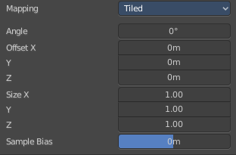
Brush Mapping with mapping method Tiled
The brush mapping method View Plane maps the brush onto the surface of the object, and tiles the pencil onto the surface. The mapping happens from the View plane. Means you get distortions when you sculpt from an angle.
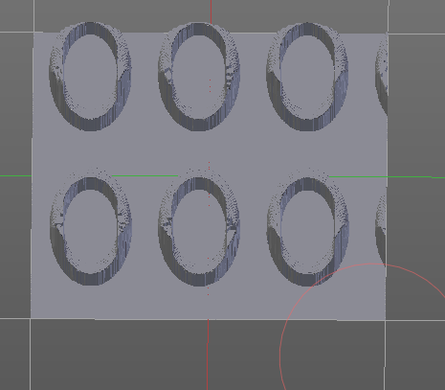

Angle edit box
Adjust the angle of the brush.

Offset
Fine tune the offset of the texture in the brush.

Size
Fine tune the size of the texture in the brush.

Sample Bias
Add to or subtract from the amount that gets added by the brush texture.

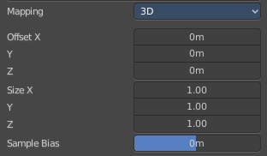
Brush Mapping with mapping method 3D
The brush mapping method View Plane and Area Plane sculpts where the pencil is. The method 3D sculpts at the initial position of the pencil, as long as you don't release the mouse. The mapping happens from the View plane. Means you get distortions when you sculpt from an angle.

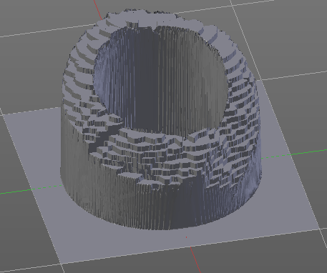
Offset
Fine tune the offset of the texture in the brush.

Size
Fine tune the size of the texture in the brush.

Sample Bias
Add to or subtract from the amount that gets added by the brush texture.

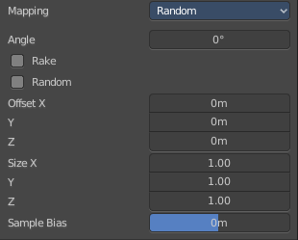
Brush Mapping with mapping method Random
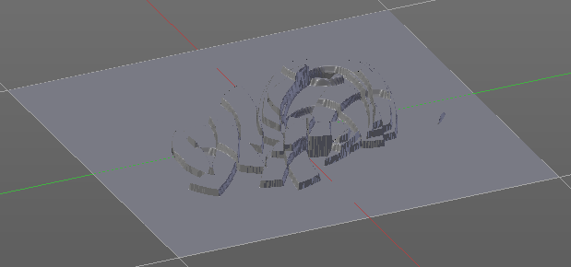
The brush mapping method Random randomizes the texture position of the pencil texture. And so it sculpts random fragments of the pencil.

Angle edit box
Adjust the angle of the brush.

Rake
The angle follows the direction of the brush stroke.

Random
The brush angle gets set random.

Random edit box
Becomes visible when you tick Random. Adjust the maximum value of the random angle.

Offset
Fine tune the offset of the texture in the brush.

Size
Fine tune the size of the texture in the brush.

Sample Bias
Add to or subtract from the amount that gets added by the brush texture.

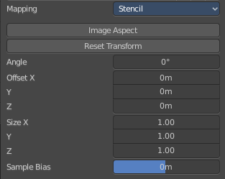
Brush Mapping with mapping method Stencil
The former methods uses the textures for the brush. The method Stencil works different. You have your texture displayed in the workspace above the object, and you paint this texture onto your object with your pencil strokes.
Note that the texture in the 3d space is just visible when you are with the mouse over the viewport.
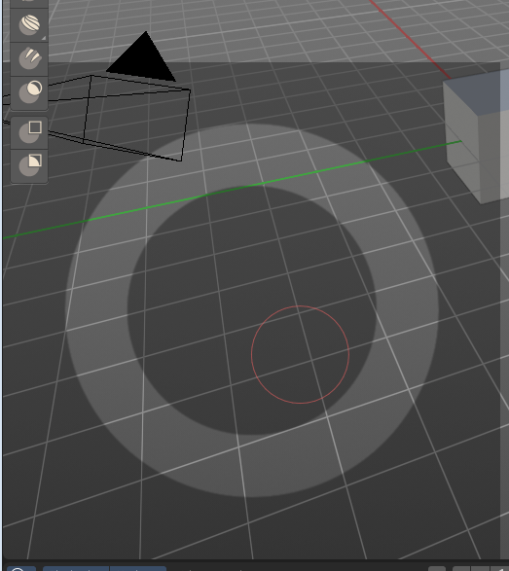

Image Aspect
Adjust the stencil size to fit to the image aspect ratio.

Angle edit box
Adjust the angle of the brush. The button at the end allows you to set the radius by dragging the mouse. This should be done in the viewport and with the hotkey. This button is just a visible reminder.

Offset
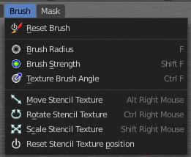
Fine tune the offset of the texture in the brush.

Stencil Texture Controls
You can find the controls to modify the position, rotation and scale of the stencil texture in the Brush menu in the 3D view. This happens by Hotkeys.

Brush Settings Panel - Stroke Sub panel
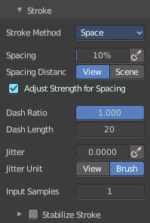
The Stroke panel contains settings to influence the behavior of the brush stroke. There are various stroke methods available. We will go through them one by one.

Stroke Panel with Stroke method Space
This is the default Stroke method. The sculpt stroke gets added continuously with given settings.
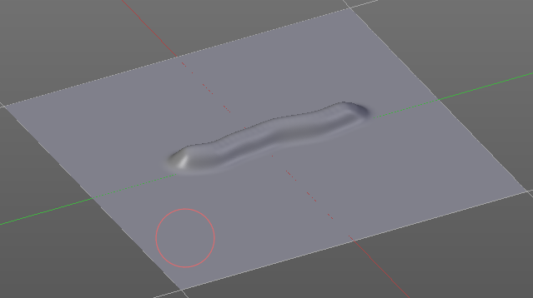

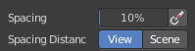
Spacing Edit Box
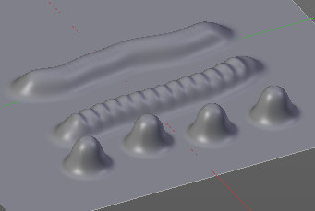
The sculpt drawing happens by mapping the pencil onto the mouse position. And when you move the mouse then the next mapping happens. Adjust the spacing after what mouse movement the next mapping should happen. The lower the value, the lower the distance between the single dots.

Spacing Pressure
The icon behind the edit box enables tablet pressure sensitivity for tablets.

Spacing Distance
If the spacing happens in View or in Scene distance.

Adjust Strength for Spacing
Automatically adjust the strength to give consistent results for different spacing.

Dash Ratio
Ratio of samples in a cycle that the brush is enabled.

Dash Length
Length of a dash cycle measured in stroke samples.

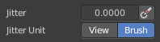
Jitter Edit Box
Add Jitter to the brush while painting.

Jitter Pressure
The icon behind the edit box enables tablet pressure sensitivity for tablets.

Jitter Unit
If the jitter happens in screen space in pixels, or relative to the brush size.

Input Samples Edit Box
Average multiple input samples together to smooth the brush stroke.

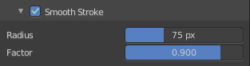
Stabilize Stroke
When activated then the brush lags behind the mouse position, and produces a much smoother stroke by that. It is a sub panel with two settings.

Smooth Stroke Radius Edit Box
Adjust the radius of the smoothing.

Smooth Stroke Factor Edit Box
Adjust the factor of the smoothing.

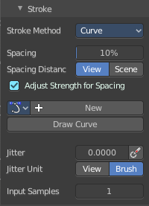
Stroke Panel with Stroke method Curve
The Stroke method curve doesn't simply influence the way how the stroke is painted.
It is a special method. First you draw a curve object by holding down ctrl and clicking with left mouse button. Then you tweak the curve. You can click at the curve point, and drag out handlers to make the curve points smooth.
Then you hit the Draw Curve button. And the curve gets sculpted.

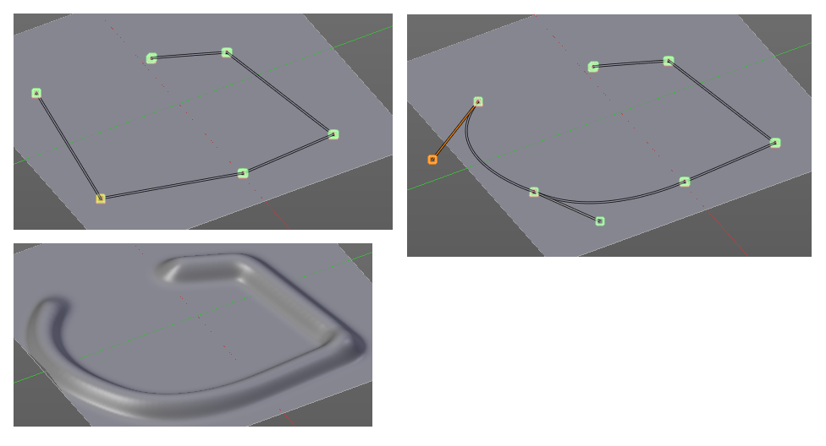

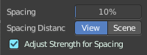
Spacing Edit Box
The sculpt drawing happens by mapping the pencil onto the mouse position. And when you move the mouse then the next mapping happens. Adjust the spacing after what mouse movement the next mapping should happen. The lower the value, the lower the distance between the single dots.
The icon behind the edit box enables tablet pressure sensitivity for tablets.

Spacing Distance
If the spacing happens in View or in Scene distance.

Adjust Strength for Spacing
Automatically adjust the strength to give consistent results for different spacing.

Paint Curve edit box
Here you set the active curve.
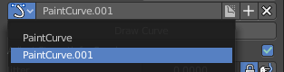
The first element is a drop down box where you will find your curves objects. You can have more than one.
The second element is the edit box that displays the active curve.
Fake User set the brush to have a fake user. Zero user data-blocks are normally not saved. But sometimes you want to force the data to be kept even when the data block has no user.
The + button allows you to add a new pencil with the current settings. Note that the brushes are NOT saved when you close Bforartists. You can save them into the current blend file. Or you can save the startup file. But be careful here. This saves everything else of the current state of Bforartists too.
The X button deletes the brush as the active one. It does NOT delete it from the brushes list.

Draw Curve Button
A click at it to turns the curve into a sculpt stroke.

Jitter Edit Box
Add Jitter to the brush while painting.

Jitter Pressure
The icon behind the edit box enables tablet pressure sensitivity for tablets.

Jitter Unit
If the jitter happens in screen space in pixels, or relative to the brush size.

Input Samples Edit Box
Average multiple input samples together to smooth the brush stroke.

Stroke Panel with Stroke method Line
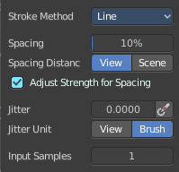
With Stroke method line you draw a line between a starting point and an endpoint. And when you release the mouse then the line gets sculpted.

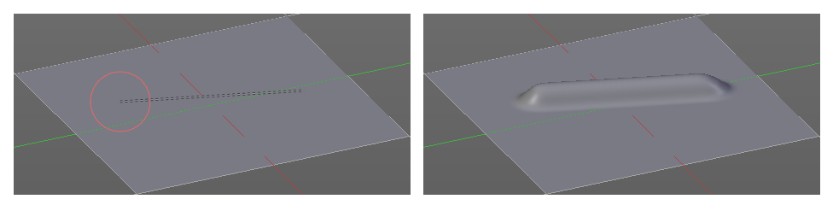

Spacing Edit Box
The sculpt drawing happens by mapping the pencil onto the mouse position. And when you move the mouse then the next mapping happens. Adjust the spacing after what mouse movement the next mapping should happen. The lower the value, the lower the distance between the single dots.
The icon behind the edit box enables tablet pressure sensitivity for tablets.

Spacing Distance
If the spacing happens in View or in Scene distance.

Adjust Strength for Spacing
Automatically adjust the strength to give consistent results for different spacing.

Jitter Edit Box
Add Jitter to the brush while painting.

Jitter Pressure
The icon behind the edit box enables tablet pressure sensitivity for tablets.

Jitter Unit
If the jitter happens in screen space in pixels, or relative to the brush size.

Input Samples Edit Box
Average multiple input samples together to smooth the brush stroke.

Stroke Panel with Stroke method Airbrush
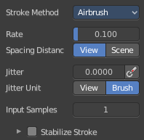
The sculpt stroke acts like an airbrush pencil. The dots gets placed randomly.
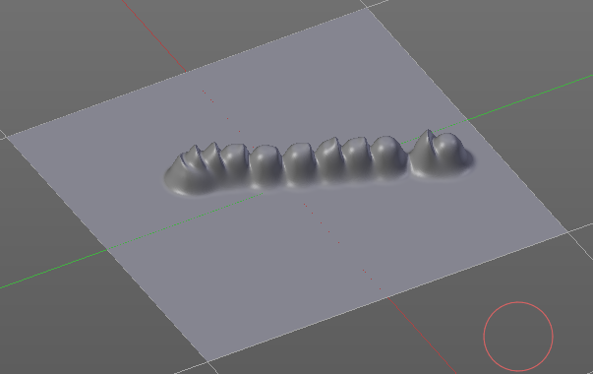

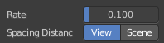
Rate Edit Box
Define the rate of the drawing.

Spacing Distance
If the spacing happens in View or in Scene distance.

Jitter Edit Box
Add Jitter to the brush while painting.

Jitter Pressure
The icon behind the edit box enables tablet pressure sensitivity for tablets.

Jitter Unit
If the jitter happens in screen space in pixels, or relative to the brush size.

Input Samples Edit Box
Average multiple input samples together to smooth the brush stroke.

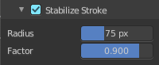
Stabilize Stroke
When activated then the brush lags behind the mouse position, and produces a much smoother stroke by that. Smooth stroke has two settings.

Smooth Stroke Radius Edit Box
Adjust the radius of the smoothing.

Smooth Stroke Factor Edit Box
Is just active when Smooth Stroke is activated. Adjust the factor of the smoothing.

Stroke Panel with Stroke method Anchored
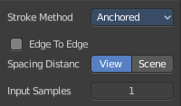
Click and drag to place a dot and to scale it.

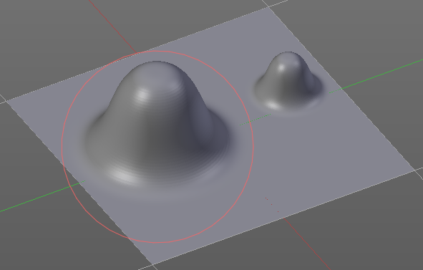

Edge to Edge
Without Edge to Edge the scaling happens from the center of the brush. With edge to edge the scaling happens from the edge of the brush.

Spacing Distance
If the spacing happens in View or in Scene distance.

Input Samples Edit Box
Average multiple input samples together to smooth the brush stroke.

Stroke Panel with Stroke method Drag dot
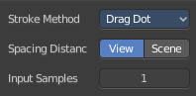
Click and drag to place a dot.

Spacing Distance
If the spacing happens in View or in Scene distance.
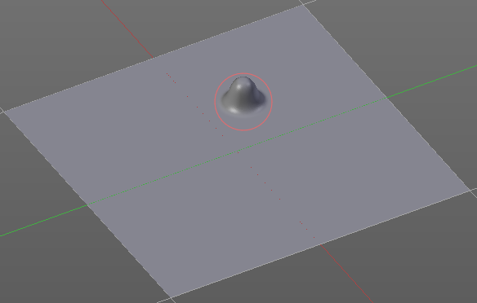

Input Samples Edit Box
Average multiple input samples together to smooth the brush stroke.

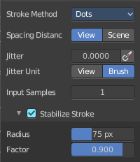
Stroke Panel with Stroke method dot
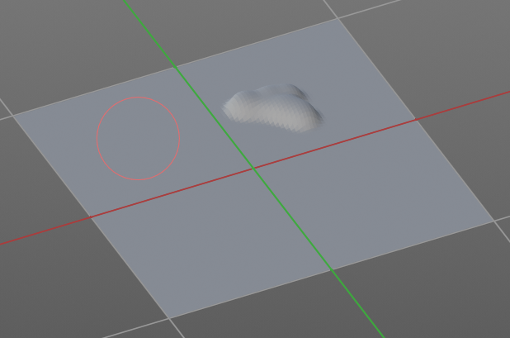

Spacing Distance
If the spacing happens in View or in Scene distance.

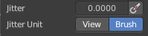
Jitter Edit Box
Add Jitter to the brush while painting.
The icon behind the edit box enables tablet pressure sensitivity for tablets.

Jitter Unit
Jitter in screen space or relative to the brush size.

Input Samples Edit Box
Average multiple input samples together to smooth the brush stroke.

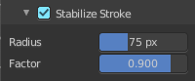
Stabilize Stroke
When activated then the brush lags behind the mouse position, and produces a much smoother stroke by that. Smooth stroke has two settings.

Smooth Stroke Radius Edit Box
Adjust the radius of the smoothing.

Smooth Stroke Factor Edit Box
Adjust the factor of the smoothing.

Brush Settings Panel - Falloff Sub panel
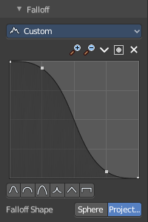
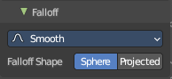
The Falloff panel allows you to define different falloffs methods for the border of the brush.

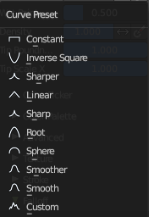
Presets
The different available falloff presets. The method custom allows you to define your own falloff. And reveals a curve panel.

Selecting Points
You can select curve points. This reveals two edit boxes for the x and y coordinate of this point.
Selected points can be moved around. Left click at them, hold the mouse button down and move them to a new location.

Adding Points
You can add new curve points by simply left clicking at the curve. Move the mouse to position them where you need it.

Navigation elements
The navigation elements at the top are described from left to right.

Zoom in and out
The two buttons with the magnifying glass at it zooms in and out in the curve window.

Tools
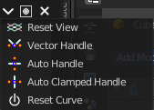
Tools is a menu where you can find some curve related tools.

Reset View
Resets the curve windows zoom.

Vector Handle
Set handle type to Vector.

Auto Handle
Set handle type to Auto.

Auto Clamped Handle
Set handle type to Auto Clamped.

Reset Curve
Resets the curve to the initial shape.


Use Clipping
Clipping options. Set up clipping for the stroke. The blue button at the top turns clipping on or off.

Delete Points
Deletes the selected curve point.


Curve Presets
Predefined curve presets as a starting point.

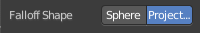
Falloff Shape
Use projected or spherical falloff.

Brush Settings Panel - Cursor Sub panel
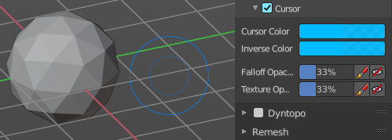
Change the appearance of the brush cursor.

Cursor checkbox in header
Show or hide the brush cursor.

Cursor Color
The cursor color with add operations.

Inverse Color
The cursor color with subtract operations.

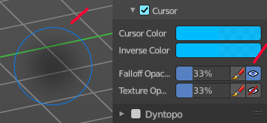
Falloff Opacity
You can turn on the cursor overlay with the eye button at the end. The falloff opacity slider allows you to adjust the opacity of this cursor overlay.

Override Overlay
Hide the Cursor Overlay when painting.

Use Cursor Overlay
Turn on Cursor Overlay.

Texture Opacity
This is for the case when you paint with a texture brush. You can turn on the Texture overlay with the eye button at the end. The falloff opacity slider allows you to adjust the opacity of this cursor overlay.

Override Overlay
Hide the Texture Overlay when painting.

Use Cursor Overlay
Turn on Texture Overlay.

Dyntopo Panel
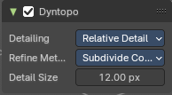
Dyntopo stands for Dynamic Topology Sculpting.
Without Dyntopo you just deform the existing geometry. With Dyntopo geometry gets subdivided when needed. This makes it possible to sculpt complex shapes out of a block.
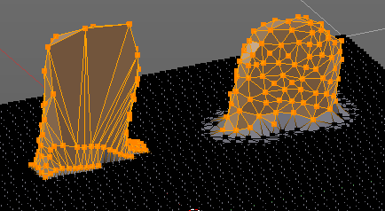
Left without Dyntopo, right with Dyntopo.
Note: Some brushes are incompatible with Dyntopo.
Brushes that are incompatible are the Grab brush, Rotate brush, Thumb brush, Layer brush, Smooth brush (including alt-key smoothing with a different brush) and Mask brush.
The topology will also not update if the stroke mode is Anchored or Drag Dot.

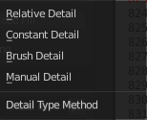
Detailing
Define the Detail Type method.

Relative Detail
Mesh Detail is relative to brush size and detail size

Brush Detail
Mesh Detail is relative to brush radius.

Constant Detail
Mesh detail is constant in object space according to detail size.

Manual Detail
Mesh detail does not change on each stroke. But just on flood fill

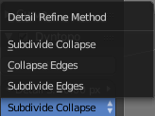
Refine method
Define the Detail refine method.

Subdivide Collapse
Both methods in one. Subdivide long edges to add mesh detail where needed. And collapse short edges to remove mesh detail where possible.

Collapse Edges
Collapse short edges to remove mesh detail where possible.

Subdivide Edges
Subdivide long edges to add mesh detail where needed.

Resolution
The Resolution defines how fine the subdivision will be.
The edit box below does the same. But with a slider, and without visible feedback in form of a widget.

Sample detail size picker
This pipette allows you to pick the current resolution from a mesh.
To activate the tool, hover with the mouse over the mesh and left click to apply.
Note: This work in the Constant and Manual methods exclusively.

Remesh Panel
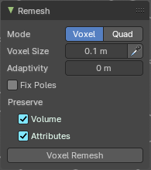
You may create a sculpt mesh that has ways too many polygons. Or too many polygons at one area, and not enough polygons at another area. Remeshing recreates the mesh geometry, with a more uniform topology.
Remesh does not work with Dyntopo enabled. You need to turn it off for remeshing.

Mode
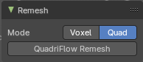
The Remesher in Sculpt mode uses the Voxel remesher by default. When you want to remesh with the Quadriflow method, then switch to Quad remesher. Quad remesher has no further options.

Voxel Size
Adjust the density of the new created geometry

Sample Detail Size
With this picker you can pick the density from an area of your mesh.

Adaptivity
Reduces the final face count by simplifying geometry where detail is not needed. This method uses tris. A value greater than 0 disables the Fix Poles feature.

Fix Poles
Produce less poles and a better topology flow.

Smooth Normals
Smooths the normals of the result.

Preserve

Volume
Tries to preserves the volume of the original mesh.

Attributes
Keep existing paint masks, face sets, vertex color and other generic mesh attributes on the new mesh.

Voxel Remesh / Quadriflow Remesh
Starts the remesh operation.

Symmetry Panel
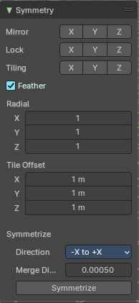
The Symmetry Lock panel contains tools around symmetry and lock features. Here you can turn on or off mirroring along axis, etc.

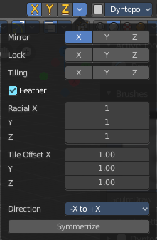
Mirror
Mirror sculpt along activated axis. By default the mirroring is activated around X axis.
The same buttons plus the whole Symmetry Lock Panel as a drop down menu can also be found in the tool settings bar as icon buttons. This allows quicker access and better visual control which mirror axis is currently active.

Lock
Disallow vertices movement in locked axis direction.

Tiling
Produces a mesh that is tilable in the activated directions.

Feather
Reduce the strength of the brush where it overlaps symmetrical daubs.

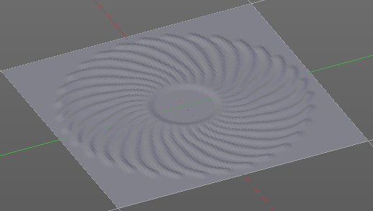
Radial
Adjust the repeating across some axis. For example, when you change Z to 32, then you can draw 32 segments simultaneously around the Z axis instead of
just one, distributed around the Z axis.

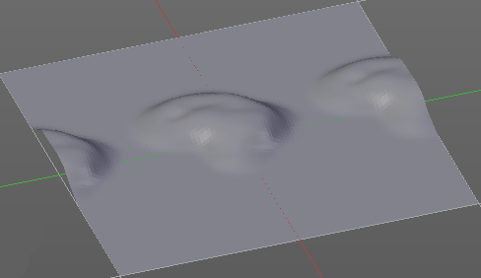
Tile Offset
Adjust the offset of the tiling.

Symmetrize

Direction
The direction in which the mirroring happens.

Merge Distance
The distance to merge vertices with symmetrizing.

Symmetrize
Symmetrize the topology modifications.

Options Panel

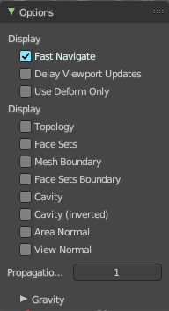
Display

Fast Navigate
For Multires, show Low Res mesh when navigating.

Delay Viewport Updates
Update the geometry when it enters the view. This enables a faster viewport navigation.

Use Deform only
Use only deformation modifiers ( The other constructive modifiers except multi-resolution gets temporary disabled)

Display

Topology
Affect only vertices connected to the active vertex under the brush.

Face Sets
Affect only vertices that share face sets with the active vertex.

Mesh Boundary
Do not affect non manifold boundary edges.

Face Sets Boundary
Do not affect vertices that belongs to a face set boundary.

Cavity
Do not affect vertices at the peaks. Based on the surface curvature.

Cavity ( Inverted)
Do not affect vertices in the valleys. Based on the surface curvature.

Area Normal
Affect only vertices with a similar normal to where the stroke starts.

View Normal
Affect only vertices with a normal that faces to the view.

Propagation Steps
Distance where boundary edge automasking is going to protect vertices from the fully masked edge.

Gravity sub panel
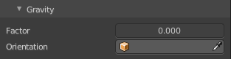
A panel with the gravity settings. Add gravity after each stroke.

Factor
The factor slider defines the amount.

Orientation
Here you define an object that gets used to determine the gravity from. The Z axis of this object gets used.

